Today: 10 April 2016 |  | Next Week: 17 April 2016
Birthdays:  Dee Dueck (10)  LeeAnne Nichols (13)  Michael Lane (14)  Pam Low (14)  Ed Vierheller (15)  Joel Manduano (16) |  | Birthdays:  Mickey Maus (19)  Sarah Smith (23)
Anniversaries:  Nancy & Joey Manduano (4/15/78) |  | Anniversaries:
Prayer this week:  Scott Morgan |  | Prayer next week  Pam Sherman
Speaker this week:  Angela Hooper |  | Speaker next week:  Lisa Davison
Snacks this week:  G = Dee Dueck  H = Janet Purinton |  | Snacks next week:  G = Ed & Judith Payton  H = Gabrielle Blankenship
Boston Avenue UMC: http://www.bostonavenue.org/ |  | Maranatha Class:  http://maranathaclass.org/
MINUTES:
Thank you for the snacks and refreshments. Angela Hooper taught on how to pray.
GUESTS:
Audrey Lewis and Allison LNU.
FINANCE:
Class expenditures: For any requested class expenditure, please contact a member of the Finance Committee: Bob Russell, Jim Embrey, Dave Grim or Karen Campbell (Emeritus) & Jim McCann.
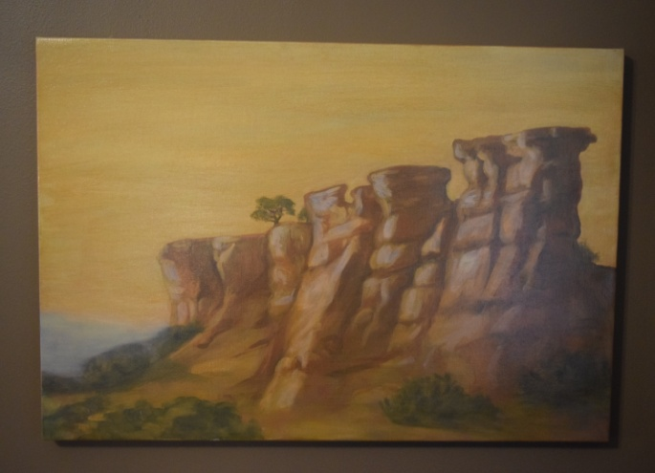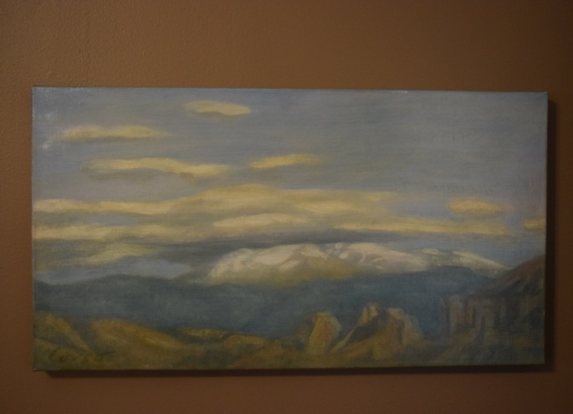
The paintings that David Cooley generously donated are still up for auction/bid. They have been listed on the following sites:
Ebay : http://www.ebay.com/itm/Oil-Paintings-by-Santa-Fe-Artist-Anthony-Corso-/162012155089?ssPageName=ADME:L:LCA:US:1123
Craigslist : http://tulsa.craigslist.org/art/5498867047.html
Ed Payton is encouraging everyone in our class to mention these on their social media sites and emailing the information to friends who might be interested in the paintings.
Here is a blurb about them: Two stunning oil paintings of the New Mexico landscape by acclaimed Santa Fe artist Anthony Corso. One is 24” x 36”; the other is 23” x 15”. The larger work depicts buttes jutting up from the floor of a valley into mesas with a distant mountain range in the background. The smaller work is of clouds hovering over a distant mountain range. Using the rich colors of the southwest, Corso captures the stark beauty of a New Mexico landscape. Corso’s work has been featured in solo shows, group exhibitions and at numerous galleries including: The Empire Collection, New York, NY; La Galleria at La Mama, New York, NY; Hankook Gallery, New York, NY; Robertson Gallery, Beverly Hills, CA; Riggs Gallery, La Jolla, CA; Labyrintus, Budapest, Hungary. His work in public collections includes those of the United Nations, the Port Authority of New York, Chemical Bank and the American Broadcasting Company. More information about the artist, who is presently living in New York, may be found at his website.
These paintings were donated to Maranatha ministries by the original owner. Proceeds will be used for community service work in the Tulsa, OK, area.
SOCIALS:

Road Trip to the Coleman Theatre – Brought back by popular demand, this event is beloved by many people in our class so the Social Committee is happy to organize the tickets and make available a trip to Miami, Oklahoma, to see the spectacular Coleman Theatre. This year, we will go on Sunday, June 12th, at noon, to hear Resident Organize Dennis James play the Mighty Wurlitzer pipe organ while we watch Buster Keaton star in the 1928 silent film Steamboat Bill, Jr. Can’t you smell that popcorn now?

MISSIONS:
Boston Avenue Service Experience (BASE) Camp: Thank you so much to everyone who represented Maranatha in working at Burroughs to improve their garden and grounds. The message you give to the students, faculty and Burroughs families about how much they matter to us is a profound one, and makes us all proud.

Upcoming Maranatha Mission Events:
22nd May: St Luke's Redemption Church, serving dinner
June – Open month for mission
24th July: St Luke's Redemption Church, serving dinner
August – Open month for mission
9th September: Day Center for the Homeless, feeding dinner
October – Open month for mission
November – Open month for mission
December – Neighbor for Neighbor, managing families for photos and presents
25 December: Serving Congregational Brunch to whole church before worship
If you know of a mission opportunity that would fit into Maranatha’s scope of work, let Glenna Arnott or Jim Embrey know so they can look into it for a possible opportunity to serve.

PRAYER VOLUNTEERS:
4/17 Pam Sherman 4/24 Pam Low
SPEAKERS:
4/17 & 24 Lisa Davison 5/1 & 8 Darlene Tegeler
CLASS PRAYER REQUESTS (Joys):
Please give thanks for the following:

Julie & Jeff Allen are thrilled to report that, after years of begging, pleading and bribing, they are finally expecting their first grandchild in September from their son & daughter-in-law.

The class rejoiced to have Debbie Jacoby well enough to return to us yesterday.

Lynn & Shari Goodwin departed yesterday for their long-awaited trip to Italy. We wish them gorgeous weather and marvelous adventures.

CLASS PRAYER REQUESTS (Concerns):
Please keep the following in your prayers:

Carol Maus’ father died Sunday afternoon after class. No details are known yet about a service or providing meals, but Caranatha will disseminate that information as soon as it is known. In the meantime, Carol, Mickey and their family would appreciate your prayers.
Judith and Ed Payton’s daughter-in-law Nikki received discouraging news at M.D. Anderson regarding potential treatment for her stomach cancer and is currently working with physicians at KU to determine how to respond.
Mary Bundren is undergoing another lengthy back surgery today and asked for prayers that it would be successful. She emailed recently that she misses everyone and hopes to be back with us in three months if this surgery reduces her pain level.
Amanda Roth Grueneberg, daughter of long time members John & Kelly Roth, developed preeclampsia and had to deliver her baby Ella prematurely. Amanda has recovered, with her blood pressure now at acceptable levels. Baby Ella is holding her own in the NICU.
Please email our Caranatha Chair Carol Grim at cgrim1@cox.net and copy our President at adale@hallestill.com with concerns that need immediate class response or prayer during the week such as accidents, injuries, deaths, etc. For emergencies, please call Carol at (918) 583-5181 (weekday mornings) or (198) 369-6945 (any other time). For Joys and Concerns to be communicated to the class and incorporated into the newsletter, please email our class mailbox at maranathaclass@gmail.com. I will incorporate them into our newsletter and, if time permits, into our class announcements, next week.

CHURCH WIDE PRAYER REQUESTS:
04/10/16 Boston Avenue Prayer Ministry: “I will be the first to love everyone I meet during the day. I will love this one and that one, and always be the first, be the first, be the first.” Chiara Lubich Jacques Cunningham, 749 7040, cunnij6@cox.net
-For God’s peace to rule in the hearts of all his children, the Boston Avenue Church & staff, the ministries of Boston Avenue, the Prayer Ministry, the ministers of Boston Avenue & families: David Wiggs, Eva Marie Campbell, Shari Goodwin, Bill Tankersley, Audra Fogle, Bill Crowell, Brenda Reed, Sheri Nellis, Sarah Thornhill, Joel Panciera, Susan Panciera, Debbie Peterson, Paula Gradney Garner, Jose Luis Hernandez, Belynda Clanton, Paul Staat, Hayley St. John, Jennifer Solis
- For Merri Whitaker, the Cookson Mission, the Burroughs students, teachers and staff
Prayer Requests Received on 4/10/16:
- For the Boston Avenue families who have lost these loved ones: Barbara Myers, James Greenay
- For these Boston Avenue members who are or have been in the hospital: Linda Hull, Gene Botkin, Lucy Staat, Ken Southard, Jewel Johnson, Amanda Roth Grueneberg, Ella Grueneberg, Cindy Cunningham, Erin Barnhart, Brady Barnhart
- For our first time visitors: BJ Beck; Alan Brown; Patsy Brown; Rebecca Brown; Emily Copsey; Fred and Kathi Crabtree; Maggie Eril; Robin Heim; Mary Hiltter; Brenda Huff; Richard Howard; Gordon Kesselring; Sahak Khackeryan, Victor Lawson; Lesa Magee; Joan McDonald; Michael Murie; Brian Rains; Lauren Shook; Ginny Thomas; Jane Tucker; Carol Von Holten; John Welborn, Margie Whitt
- For the Diesenroth family- that God will watch over them while they are grieving and Minnie Jean Gibson- for good health.
- For Paul Staat for healing and provision
- For Cindy Harmon - recurrence of lung cancer. Starting chemotherapy and will be off work for several months.
- For Donald Kupka. Dad is having open heart surgery bypass surgery.
- For the growth of Alcott Ministries. May God continue and grow its good works.
- For the blessing and growth of all Boston Avenue’s ministries and all staff & volunteers.
- For Ed & Judith Payton’s family member with gastric cancer.
- For Jim Redmond blood clot in leg requiring stent replacement. Recovering at home now
- For Michele Price skin carcinoma removal & biopsy. Fell injuring her back & ribcage.
- For Dee Blackwelder. Diagnosed with thyroid cancer. Awaiting treatment decisions.
- For Louise Reid. She fell at church and went to the hospital.
- For Gerry Arnold who is having heart surgery.
- For Peggy Nail concerning a rent raise. Financial situation is bad & I need colon hernia surgery.
- For Christy Handcock on Medicaid. Will be devastating for her and others if state cuts services. Pray for the Governor and state to not make these cuts.

ANNOUNCEMENTS:
A PATH APPEARS: TRANSFORMING LIVES, CREATING OPPORTUNITY: The Joy Circle of Boston Avenue UMW is sponsoring an opportunity to screen the movie “A Path Appears” on May 1, 2016 from noon to 3:00 p.m. The movie is a powerful film about gender-based oppression and human rights violations, as well as the effective solutions being implemented to combat them. Lunch is offered for $10.00 and childcare is available, but reservations for each are needed by April 27th. Contact Rev. EvaMarie Campbell at (918) 699-0120 or evamarie68@gmail.com
ALZHEIMER’S INFORMATION MEETING – As part of a campaign to help our church be better prepared by putting a face on aging issues such as dementia and Alzheimer’s, BAUMC is hosting a free congregational gathering entitled “Facing Dementia as a Church Family” at 6:30 on Thursday, April 21st. Will Randolph, Director of Aging and Older Adult Ministries at the United Methodist Church in Nashville will be featured and representatives from the Alzheimer’s Association Oklahoma Chapter will be available with resources and information. RSVP to (918) 699-0127, as space is limited for the event.
CLASS DISCUSSION GUIDELINES - We are a large class with many people who have lots of interesting things to say. In order to give everyone an opportunity to voice their comments, we are incorporating into our weekly lessons the discussion guidelines that Marita Morgan taught us: (1) Only one comment per person per class. (2) Economy of words. (3). Speak loudly so everyone has an opportunity to hear you. Thank you for adhering to these discussion guidelines so that we will all have an opportunity to participate in the discussions and benefit from hearing each other.
2016 Maranatha Officers
President: Jim McCann
VP Curriculum: Michelle Place
VP Finance: Bob Russell/Jim Embrey/Dave Grim/Karen Campbell (Emeritus)/Jim McCann
VP Missions: Glenna Arnott/Jim Embrey
Social: Angelyn Dale/Karen Campbell/Sarah Maldonado/Jeanie Payton/Judith Payton
Auction: Judith and Ed Payton
Attendance taker(s)/Secretary: Sharon Earley
Refreshments: Debbie and Scott Morgan
Reporter: Meredith Davison-Wansley
Caranatha: Carol and Dave Grim
Chili Supper: Jim & Julee Embrey
Historian: Pam Low
Treasurer: Susie Butterworth
Web Master: Barbara Meehan

