Today: 3 April 2016 |  | Next Week: 10 April 2016
Birthdays:  Rob Reck (7) |  | Birthdays:  Dee Dueck (10)  LeeAnne Nichols (13)  Michael Lane (14)  Pam Low (14)  Ed Vierheller (15)  Joel Manduano (16)
Anniversaries:  Martha & Dan Blevins (4/7/84)  Sherry & Jim Griffin (4/7/07)  Judy & John Harkins (4/9/10) |  | Anniversaries:  Nancy & Joey Manduano (4/15/78)
Prayer this week:  Lynn Jessee |  | Prayer next week  Scott Morgan
Speaker this week:  Angela Hooper |  | Speaker next week:  Angela Hooper
Snacks this week:  G = Julee & Jim Embrey  H = Sarah & Cisco Maldonado |  | Snacks next week:  G = Dee Dueck  H = Janet Purinton
Boston Avenue UMC: http://www.bostonavenue.org/ |  | Maranatha Class:  http://maranathaclass.org/
MINUTES:
Thank you for the snacks and refreshments. Angela Hooper taught an excellent lesson on how to pray and we are looking forward to the second part of her series this Sunday.
GUESTS:
None.
FINANCE:
Class expenditures: For any requested class expenditure, please contact a member of the Finance Committee: Bob Russell, Jim Embrey, Dave Grim or Karen Campbell (Emeritus) & Jim McCann.
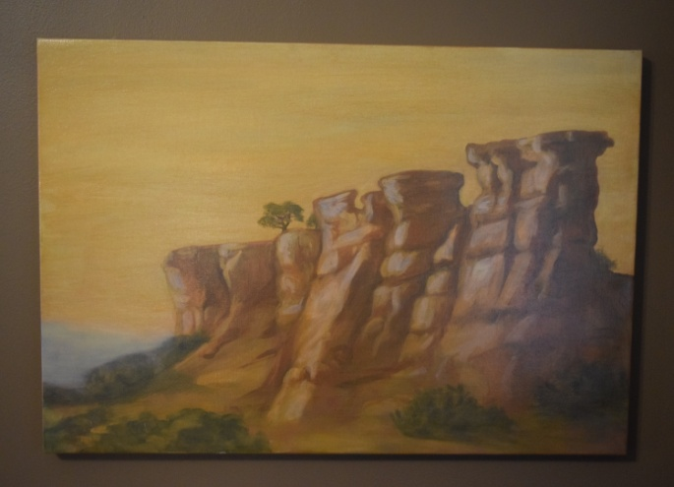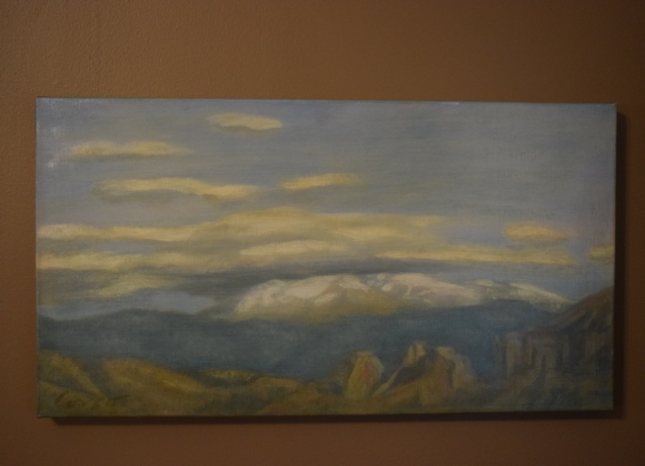
The paintings that David Cooley generously donated are still up for auction/bid. They have been listed on the following sites:
Ebay : http://www.ebay.com/itm/Oil-Paintings-by-Santa-Fe-Artist-Anthony-Corso-/162012155089?ssPageName=ADME:L:LCA:US:1123
Craigslist : http://tulsa.craigslist.org/art/5498867047.html
Ed Payton is encouraging everyone in our class to mention these on their Facebook page by posting information, the photos and links to these two sites. It would also be helpful if you could email the information to some of your friends who may be interested in the paintings.
Here is a blurb about them: Two stunning oil paintings of the New Mexico landscape by acclaimed Santa Fe artist Anthony Corso. One is 24” x 36”; the other is 23” x 15”. The larger work depicts buttes jutting up from the floor of a valley into mesas with a distant mountain range in the background. The smaller work is of clouds hovering over a distant mountain range. Using the rich colors of the southwest, Corso captures the stark beauty of a New Mexico landscape. Corso’s work has been featured in solo shows, group exhibitions and at numerous galleries including: The Empire Collection, New York, NY; La Galleria at La Mama, New York, NY; Hankook Gallery, New York, NY; Robertson Gallery, Beverly Hills, CA; Riggs Gallery, La Jolla, CA; Labyrintus, Budapest, Hungary. His work in public collections includes those of the United Nations, the Port Authority of New York, Chemical Bank and the American Broadcasting Company. More information about the artist, who is presently living in New York, may be found at his website.
These paintings were donated to Maranatha ministries by the original owner. Proceeds will be used for community service work in the Tulsa, OK, area.
SOCIALS:

Road Trip to the Coleman Theatre – Brought back by popular demand, this event is beloved by many people in our class so the Social Committee is happy to organize the tickets and make available a trip to Miami, Oklahoma, to see the spectacular Coleman Theatre. This year, we will go on Sunday, June 12th, at noon, to hear Resident Organize Dennis James play the Mighty Wurlitzer pipe organ while we watch Buster Keaton star in the 1928 silent film Steamboat Bill, Jr. Can’t you smell that popcorn now?

MISSIONS:
Boston Avenue Service Experience (BASE) Camp is coming this Sunday, April 10th!
1. If you didn’t sign up in Bishop’s Hall and in Maranatha, but are now available to help, please contact Glenna Arnott or Jim Embrey so we can plan our projects and arrange for lunch.
2. Wear your work clothes to church on April 10th.
3. Eat lunch in Jubilee Hall after the 11:00 service.
4. After lunch head over (convoy) to Burroughs Elementary at 1924 N. Cincinnati Ave, Tulsa, OK 74106. If you need a ride, contact Glenna Arnott or Jim Embrey to arrange it.
5. Most of our work will consist of picking up light trash around the property, pulling weeds out of the playground areas and small gardens, replacing the hoops on the basketball court, and a little weed eating/whacking.
6. We will be done within three hours or less. Bring your work gloves, hats, boots, and whatever you are comfortable wearing outdoors.
7. We will have bottled water available, but no bathroom facilities on the premises.

Upcoming Maranatha Mission Events:
10 April – Burroughs Elementary, outside clean up and light garden work
22nd May: St Luke's Redemption Church, serving dinner
June – Open month for mission
24th July: St Luke's Redemption Church, serving dinner
August – Open month for mission
9th September: Day Center for the Homeless, feeding dinner
October – Open month for mission
November – Open month for mission
December – Neighbor for Neighbor, managing families for photos and presents
25 December: Serving Congregational Brunch to whole church before worship
If you know of a mission opportunity that would fit into Maranatha’s scope of work, let Glenna Arnott or Jim Embrey know so they can look into it for a possible opportunity to serve.

PRAYER VOLUNTEERS:
4/10 Scott Morgan 4/17 Pam Sherman
4/24 Still need volunteer for this day!
SPEAKERS:
4/10 Angela Hooper 4/17 & 24 Lisa Davison
CLASS PRAYER REQUESTS (Joys):
Please give thanks for the following:

Lucy Staat, infant granddaughter of Paul & Mary Staat, has finally become able to regulate her own temperature and has been released from the hospital to come home.

CLASS PRAYER REQUESTS (Concerns):
Please keep the following in your prayers:

Karen Harris’ father has been moved to hospice care in his battle with terminal illness.
Judith and Ed Payton’s daughter-in-law Nikki is being treated for stomach cancer at M. D. Anderson. Those of us who purchased the Farm to Table Dinner last year had the pleasure of meeting Nikki and eating her wonderful food.
Paul Staat is waiting on an appropriate T cell donor to proceed with his treatment.
Mary Bundren’s recent back surgery was regrettably unsuccessful, so she will be having an additional back surgery.
Bethany Willyard is having back surgery on April 18th.
Jim Seymour has been diagnosed with two different types of cancer and is determining appropriate treatment options.
Nancy Manduano’s mother has been admitted to the hospital for treatment of dementia.
Amanda Roth Gruenebery, daughter of long time members John & Kelly Roth, developed preeclampsia and had to deliver her baby Ella at 24 weeks. Amanda has recently been released from the hospital after struggling to get her blood pressure back down to appropriate levels. Baby Ella will remain in the NICU for an extended period.
Dave Shepherd requested prayer for all of the Williams employees worried about whether they will lose their jobs and Susan Day requested prayer for all unemployed people in Tulsa.
Please email our Caranatha Chair Carol Grim at cgrim1@cox.net and copy our President at adale@hallestill.com with concerns that need immediate class response or prayer during the week such as accidents, injuries, deaths, etc. For emergencies, please call Carol at (918) 583-5181 (weekday mornings) or (198) 369-6945 (any other time). For Joys and Concerns to be communicated to the class and incorporated into the newsletter, please email our class mailbox at maranathaclass@gmail.com. I will incorporate them into our newsletter and, if time permits, into our class announcements, next week.

CHURCH WIDE PRAYER REQUESTS:
04/03/16 Boston Avenue Prayer Ministry: “Thank you, Jesus, for taking the clay of my existence in your tender hands and turning it into a vessel of grace. My beauty does not depend on perfection. Just as the unique flaws in any work of art increase its value, so does my humdrum everyday life refract the light of your boundless love, O Lord.” Susan Muto Jacques Cunningham, 749 7040, cunnij6@cox.net
-For God’s peace to rule in the hearts of all his children, the Boston Avenue Church & staff, the ministries of Boston Avenue, the Prayer Ministry, the ministers of Boston Avenue & families: David Wiggs, Eva Marie Campbell, Shari Goodwin, Bill Tankersley, Audra Fogle, Bill Crowell, Brenda Reed, Sheri Nellis, Sarah Thornhill, Joel Panciera, Susan Panciera, Debbie Peterson, Paula Gradney Garner, Jose Luis Hernandez, Belynda Clanton, Paul Staat, Hayley St. John
- For Merri Whitaker, the Cookson Mission, the Burroughs students, teachers and staff
Prayer Requests Received on 4/3/16:
- For the Boston Avenue families who have lost these loved ones: Norma Dattle
- For these Boston Avenue members who are or have been in the hospital: Linda Hull, Lonnie Mill, Alfreda Rudd, Olin Holmes, Ken Southard, Amanda Roth Gruenebery, Ella Gruenebery, Lucy Staat
- For our first time visitors:
- For Gene Botkin who got his pace maker and is doing better.
- For Shelly & Jim Owen & Stephanie Barber. Stephanie & I will become co-guardians of our Uncle Jim who has developmental disabilities on April 5. Jim lives in a group home in Muskogee.
- For Jack Martin who will be starting radiation & chemo for cancer
- For John Haliburton who lives in Jackson MS. No family members close to him. He suffered a massive stroke in Methodist Rehabilitation Hospital on 3/20/16.
- For P. Scott healing from respiratory problems, congestive hypertension & bad knee torn ligament.
- For Janet speedy healing from foot surgery.
-For Corey Allen Scott. Corey has meth addiction. He was picked up by TPD Wed. They filed 2 felony charges 1) for possession of meth 2) for being with 1000ft of a school with meth.
- For Melissa & for all losing my uncle. Pray for strength.
- For Stephan with prostate cancer and radiation treatment.
- For Rodney. He is in hospital. I don’t know the nature of what’s wrong at this time.
-For Jerome Combs.
-Going through rough divorce. Am hearing impaired can’t hear. Getting a hearing aid but the place only gives one (need 2) need bed & furniture etc.
- For Cindy recovering from knee replacement and for Doug with terminal cancer and his wife Janet.

ANNOUNCEMENTS:
ALZHEIMER’S INFORMATION MEETING – As part of a campaign to help our church be better prepared by putting a face on aging issues such as dementia and Alzheimer’s, BAUMC is hosting a free congregational gathering entitled “Facing Dementia as a Church Family” at 6:30 on Thursday, April 21st. Will Randolph, Director of Aging and Older Adult Ministries at the United Methodist Church in Nashville will be featured and representatives from the Alzheimer’s Association Oklahoma Chapter will be available with resources and information. RSVP to (918) 699-0127, as space is limited for the event.
MISSION TEAM FORMING TO SERVE COOKSON HILLS CENTER ON JUNE 5-10, 2016: Twenty participants are sought to perform mission work in the areas of maintenance, odd jobs and repairs at Cookson facilities. Accommodations include bunk beds, air-conditioning, bathrooms, showers, and laundry. Cost is $200 to $250 per person. Sign-ups are in Bishops’ Hall.
CLASS DISCUSSION GUIDELINES - We are a large class with many people who have lots of interesting things to say. In order to give everyone an opportunity to voice their comments, we are incorporating into our weekly lessons the discussion guidelines that Marita Morgan taught us: (1) Only one comment per person per class. (2) Economy of words. (3). Speak loudly so everyone has an opportunity to hear you. Thank you for adhering to these discussion guidelines so that we will all have an opportunity to participate in the discussions and benefit from hearing each other.

2016 Maranatha Officers
President: Jim McCann
VP Curriculum: Michelle Place
VP Finance: Bob Russell/Jim Embrey/Dave Grim/Karen Campbell (Emeritus)/Jim McCann
VP Missions: Glenna Arnott/Jim Embrey
Social: Angelyn Dale/Karen Campbell/Sarah Maldonado/Jeanie Payton/Judith Payton
Auction: Judith and Ed Payton
Attendance taker(s)/Secretary: Sharon Earley
Refreshments: Debbie and Scott Morgan
Reporter: Meredith Davison-Wansley
Caranatha: Carol and Dave Grim
Chili Supper: Jim & Julee Embrey
Historian: Pam Low
Treasurer: Susie Butterworth
Web Master: Barbara Meehan

