Today: 1 May 2016 |  | Next Week: 8 May 2016
Birthdays:  Brenda Worthington (1)  Susie Butterworth (4)  Kirk Place (5) |  | Birthdays:  John Nicks (8)  Paula Scott (11)  Jim Embrey (13)
Anniversaries:  Margaret & Dave Been (5/1/72)  Charlotte & Roger Rowe (5/6/78) |  | Anniversaries:
Prayer this week:  Paula Scott |  | Prayer next week  Jerry LeDoux
Speaker this week: |  | Speaker next week:  Darlene Tegeler
Snacks this week:  G = Dave & Carol Grim  H = Mark & Susie Butterworth |  | Snacks next week:  G = Nancy & Joey Manduano  H = James Kilman
Boston Avenue UMC: http://www.bostonavenue.org/ |  | Maranatha Class:  http://maranathaclass.org/
MINUTES:
Thank you for the snacks and refreshments, and thanks to Mickey Maus for the emergency Rice Krispie Treat run! Thanks also to the entire class for being so gracious about not having a speaking and for speaking up and sharing so that our time together was still meaningful. You are the best!
GUESTS:
Wanda Williamson, Jane Sathyaden, Logan Rogers. We were also thrilled to welcome home our own Nancy Christy!
FINANCE:
Class expenditures: For any requested class expenditure, please contact a member of the Finance Committee: Bob Russell, Jim Embrey, Dave Grim or Karen Campbell (Emeritus) & Jim McCann.
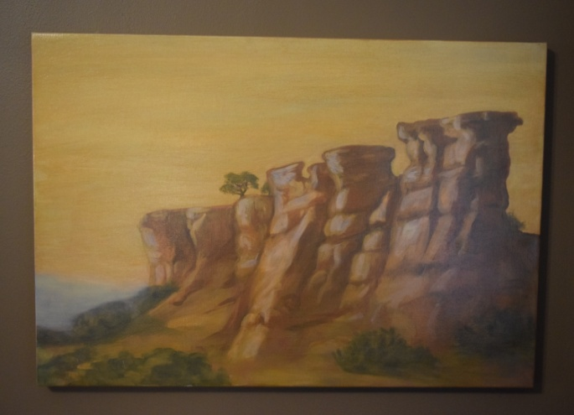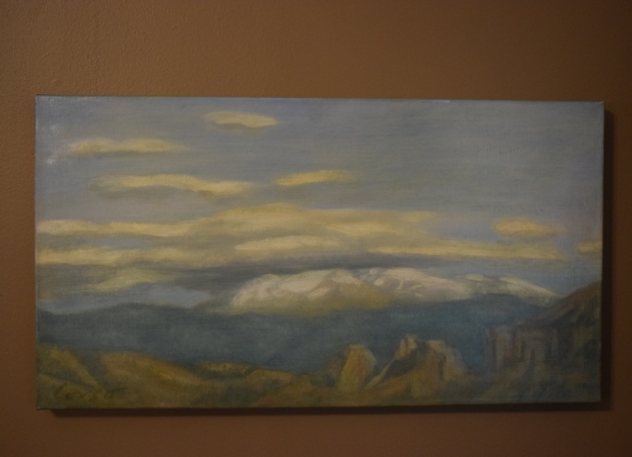
The paintings that David Cooley generously donated are still up for auction/bid. They have been listed on the following sites:
Ebay : http://www.ebay.com/itm/Oil-Paintings-by-Santa-Fe-Artist-Anthony-Corso-/162012155089?ssPageName=ADME:L:LCA:US:1123
Craigslist : http://tulsa.craigslist.org/art/5498867047.html
Ed Payton is encouraging everyone in our class to mention these on their social media sites and emailing the information to friends who might be interested in the paintings.
Here is a blurb about them: Two stunning oil paintings of the New Mexico landscape by acclaimed Santa Fe artist Anthony Corso. One is 24” x 36”; the other is 23” x 15”. The larger work depicts buttes jutting up from the floor of a valley into mesas with a distant mountain range in the background. The smaller work is of clouds hovering over a distant mountain range. Using the rich colors of the southwest, Corso captures the stark beauty of a New Mexico landscape. Corso’s work has been featured in solo shows, group exhibitions and at numerous galleries. His work in public collections includes those of the United Nations, the Port Authority of New York, Chemical Bank and the American Broadcasting Company. More information about the artist, who is presently living in New York, may be found at his website.
These paintings were donated to Maranatha ministries by the original owner. Proceeds will be used for community service work in the Tulsa, OK, area.
SOCIALS:

Road Trip to the Coleman Theatre – The Social Committee is organizing a road trip to Miami, Oklahoma, to the spectacular Coleman Theatre on Sunday, June 12th, at noon, to hear Resident Organist Dennis James play the Mighty Wurlitzer pipe organ while we watch Buster Keaton star in the 1928 silent film Steamboat Bill, Jr. Can’t you smell that popcorn now?

MISSIONS:
Upcoming Maranatha Mission Events:
22nd May: St Luke's Redemption Church, serving dinner
June – Open month for mission
24th July: St Luke's Redemption Church, serving dinner
August – Open month for mission
9th September: Day Center for the Homeless, feeding dinner
October – Open month for mission
November – Open month for mission
December – Neighbor for Neighbor, managing families for photos and presents
25 December: Serving Congregational Brunch to whole church before worship
If you know of a mission opportunity that would fit into Maranatha’s scope of work, let Glenna Arnott or Jim Embrey know so they can look into it for a possible opportunity to serve.

PRAYER VOLUNTEERS:
5/8 Jerry LeDoux 5/15 Meredith Davison
5/22 Pam Sherman 5/29 Lynn Jessee

SPEAKERS:
5/8 Darlene Tegeler 5/15 Rabbi Charles Sherman
5/22 Rev. Susanna Southard 5/29 Brunch w/Horizons
CLASS PRAYER REQUESTS (Joys):
Please give thanks for the following:

David Rose has completed six of his nine weeks of radiation treatments for prostate cancer and has not had any significant side effects.

Carol Grim is very grateful for the support provided by the class and the church for the Quilting Ministry and the good work that such support allows the Quilting Ministry to provide.

Bethany Willyard is recovering from her recent back surgery and appreciates all the prayers from this class.

John & Kelly Roth saw their premature grandbaby Ella for the first time at 34 days old. She is now the size of a ruler. Kelly described the experience of seeing her as “overwhelming.”

CLASS PRAYER REQUESTS (Concerns):
Please keep the following in your prayers:

Ed Vierheller’s grandson was severely injured in a car accident on Thursday, April 21st. He suffered numerous broken bones and has not regained consciousness since the accident.
Nancy Manduano’s mother has been diagnosed with Alzheimer’s and her family is suffering with the devastating effects of the disease.
Jim Griffin left for Florida (along with Sherri) to consult physicians in Florida regarding his future medical treatment.
Paul Staat will be leaving for M.D. Anderson on Saturday to start the process for his bone marrow transplant from his sister. Mary will be finishing things at school and leaving shortly before the school year ends.
Our guest Jane Sathyaden will be traveling to Brazil to spend time with her 19-year-old son who is having some difficulties.
Please email our Caranatha Chair Carol Grim at cgrim1@cox.net and copy our President at adale@hallestill.com with concerns that need immediate class response or prayer during the week such as accidents, injuries, deaths, etc. For emergencies, please call Carol at (918) 583-5181 (weekday mornings) or (198) 369-6945 (any other time). For Joys and Concerns to be communicated to the class and incorporated into the newsletter, please email our class mailbox at maranathaclass@gmail.com. I will incorporate them into our newsletter and, if time permits, into our class announcements, next week.

CHURCH WIDE PRAYER REQUESTS:
05/1/16 Boston Avenue Prayer Ministry: “You have heard it said shoot first and ask questions later. But I say to you love first and ask questions later.” Paraphrase of Jesus Jacques Cunningham, 749 7040, cunnij6@cox.net
-For God’s peace to rule in the hearts of all his children, the Boston Avenue Church & staff, the ministries of Boston Avenue, the Prayer Ministry, the ministers of Boston Avenue & families: David Wiggs, Eva Marie Campbell, Shari Goodwin, Bill Tankersley, Audra Fogle, Bill Crowell, Brenda Reed, Sheri Nellis, Sarah Thornhill, Joel Panciera, Susan Panciera, Debbie Peterson, Paula Gradney Garner, Jose Luis Hernandez, Belynda Clanton, Paul Staat, Hayley St. John, Jennifer Solis
- For Merri Whitaker, the Cookson Mission, the Burroughs students, teachers and staff

Prayer Requests Received on 5/1/16:
- For the Boston Avenue families who have lost loved ones.
- For the Boston Avenue members who are or have been in the hospital.
- For our first time visitors.
- I am an Episcopal priest who has early onset Alzheimer's which is causing me to go blind. Thank you for being on TV for us who cannot drive but give thanks to our loving GOD. I am a shut in but you delight me no end. I may be blind soon but I will hear you every week. God bless you to no end.
- For Luci Scott, a BA member diagnosed with cancer of the gums who will have surgery.
- For Candy Wiggins in Tenn. with health issues
- for the Methodist General Conference and Oklahoma Conference
- For my broken heart.
- For Conner Saunders born at 24 weeks – now 41 weeks with many complications.
- For Courtney Carruth. Housing prayers answered when I moved into my new apartment on the 9th. But I still need a part time job.
- For Alexis Hill & Domink Heinaman, for all of us to be reunited and healing as a family.
- For Steven recovering from cancer.
- For Jerome Combs.
- For spiritual revival for America. May it start in Tulsa and at Boston Avenue.
- For Debbie. Long term mental illness, great difficulty with changing medication. Hard on caregivers – my sister and nephew. Live in Fort Smith, AR.
- For Madison Gamble, severely injured when a concrete column fell on her at Edison High School. She has severe intestinal infection & surgery for broken crushed pelvis, broken legs, perforated bowel.
- For Woody Knox prostate issues.
- For Ray & Barbara. Ray was diagnosed with abdominal tumors.
- For David Schroeder whose wife Lauren, son Noah, and other family members were in an auto accident Friday night. I think they are ok but it was really scary.
- For Deaconess Becky Louter, the executive general secretary of the office of Deaconess and Home Missioners. She has battled breast cancer for a few years & has had a setback. Pray for Scott Vickery who is doing his own job & covering her responsibilities and for their families.
- For Sammy Lewis in agonizing pain from back surgery & his family and for Gina in a great deal of pain

ANNOUNCEMENTS:
APPRECIATION FOR BURROUGHS VOLUNTEERS: If you have volunteered for Burroughs Elementary school during the past school year, and can attend a Burrough’s Volunteer Breakfast on Friday, May 6th at 9:00 a.m., please RSVP to the school office by May 2nd. The school is located at 1924 MLK Jr. Blvd., Tulsa, OK 74106 The event will be in the school library.
BOY SCOUT SUPPORT NEEDED: Can you write a brief letter to a young boy who would like to hear from you? Could you buy a bag of candy? If so, you could do something really great for our own Troop 20 at Boston Avenue. Audra Fogle is asking each class to support our Boy Scouts going to summer camp. Maranatha would provide 5-10 letters to young boys going to summer camp. It would be particularly meaningful if these letters could be written by men who were scouts or families who had scounts who are willing to share those camp stories with the current young fellows! Letters need to be returned to Audra no later than Sunday, May 29th, so that the Welcoming Committee can assemble a care package for each boy. Maranatha is also being asked to donate non-chocolate candy to go in the care packages and that should be delivered to Audra by May 29th as well. Since ours is the oldest continuously chartered troop in the State of Oklahoma, Boston Avenue has been standing behind our scouts for many, many years. Let’s continue to participate in this meaningful tradition by supporting our scouts.
ITALIAN DINNER AUCTION ITEM: For those who purchased the Italian Dinner at the Maranatha Christmas Auction, it will be held on Saturday, May 14th, at the home of Jim and Sherry Griffin, 1376 E. 26th St. Tulsa, OK 74114. The exact start time will be announced on an invitation that will be sent soon. The hosts for the event are the Griffins, the Donleys and Richard and Jeanie Payton.
RETURNING CHARTER MEMBERS NEED WELCOME VISITS: As indicated in the email sent to the class, charter Maranatha members Sharon and Bruce Chucoski moved back to Tulsa on Tuesday, April 19th. We are hoping that they will decide to rejoin us in the Maranatha Class. If current class members could stop by and welcome them over the next few days at 3728 E. 64th Pl. (Pointe South), that warm Maranatha welcome might just seal the deal!
GARAGE APARTMENT AVAILABLE FROM JAMES KILMAN: A 350 square foot guest house is available for rent on June 1, 2016, by James Kilman close to downtown. The unit includes a stove, refrigerator and built-in queen size Murphy bed with mattress provided. Hook-ups are available for an over/under washer/dryer unit. James is asking $700 per month in rent with water included. Additional utilities (electric and gas) typically run around $150 per month. Please contact James at (918) 557-5131 for additional information or a showing.
COOKSON HILLS MISSION CREW -UPDATED INFORMATION: Applications are being accepted for a mission crew to provide a week of support, maintenance and repair work from June 5th through 10th to assist the Cookson Hills Mission with its continuing mission efforts in the Cherokee Nation. THIS IS FREE TO PARTICIPANTS. WORKERS WILL TRAVEL BACK AND FORTH EACH STAY SO THEY CAN STAY IN THEIR OWN HOMES. WEDNESDAY IS A DAY OFF. WORKERS CAN COME FOR AS MANY DAYS AS THEY ARE ABLE. EVEN ONE DAY WOULD MAKE AN IMPACT ON MISSION WORK. Contact Jim Stilwell at (918) 884-5189 for additional information.
SPAVINAW VBS MISSION TEAM FORMING: Would you like to make a difference in the life of a young child while staying close to home? Come join the mission team that will assist with Vacation Bible School at the Spavinaw United Methodist Church. Although the church has a total membership of 20-25 people, it attract 50-60 children each year for VBS and needs our help to make this a wonderful experience for them. The buses will leave Boston Avenue each day for the 90 minute drive to Spavinaw where lunch will be provided for you before you return home. Won’t you consider blessing others and being blessed by this endeavor? Contact Penny Sheehan at (918)698-8778 for more information.
CLASS DISCUSSION GUIDELINES - We are a large class with many people who have lots of interesting things to say. In order to give everyone an opportunity to voice their comments, we are incorporating into our weekly lessons the discussion guidelines that Marita Morgan taught us: (1) Only one comment per person per class. (2) Economy of words. (3). Speak loudly so everyone has an opportunity to hear you. Thank you for adhering to these discussion guidelines so that we will all have an opportunity to participate in the discussions and benefit from hearing each other.
2016 Maranatha Officers
President: Jim McCann
VP Curriculum: Michelle Place
VP Finance: Bob Russell/Jim Embrey/Dave Grim/Karen Campbell (Emeritus)/Jim McCann
VP Missions: Glenna Arnott/Jim Embrey
Social: Angelyn Dale/Karen Campbell/Sarah Maldonado/Jeanie Payton/Judith Payton
Auction: Judith and Ed Payton
Attendance taker(s)/Secretary: Sharon Earley
Refreshments: Debbie and Scott Morgan
Reporter: Meredith Davison-Wansley
Caranatha: Carol and Dave Grim
Chili Supper: Jim & Julee Embrey
Historian: Pam Low
Treasurer: Susie Butterworth
Web Master: Barbara Meehan

