Today: 8 May 2016 |  | Next Week: 15 May 2016
Birthdays:  John Nicks (8)  Paula Scott (11)  Jim Embrey (13) |  | Birthdays:  Clark Bundren (20)
Anniversaries: |  | Anniversaries:  David & Kendall Carpenter (5/21/83)
Prayer this week:  Jerry LeDoux |  | Prayer next week  Meredith Davison-Wansley
Speaker this week:  Darlene Tegeler |  | Speaker next week:  Rabbi Sherman IN COMMUNITY HALL!!!
Snacks this week:  G = Nancy & Joey Manduano  H = James Kilman |  | Snacks next week:  G = Sherry & Jim Griffin  H = Richard & Meredith Wansley
Boston Avenue UMC: http://www.bostonavenue.org/ |  | Maranatha Class:  http://maranathaclass.org/
MINUTES:
Thank you for the snacks and refreshments. Darlene Tegeler taught us on the half truth of the saying, “Everything happens for a reason.” NEXT WEEK WE MEET IN COMMUNITY HALL TO HEAR RABBI SHERMAN WITH THE PILGRIMAGE CLASS SO DON’T GET LOST!!! We will lure you down there with coffee and snacks. If you need a trail of breadcrumbs to find it, let me know.
GUESTS:
Olin Medley and Logan Rogers. There was also a brief sighting of Taylor Davis.
FINANCE:
Class expenditures: For any requested class expenditure, please contact a member of the Finance Committee: Bob Russell, Jim Embrey, Dave Grim or Karen Campbell (Emeritus) & Jim McCann.
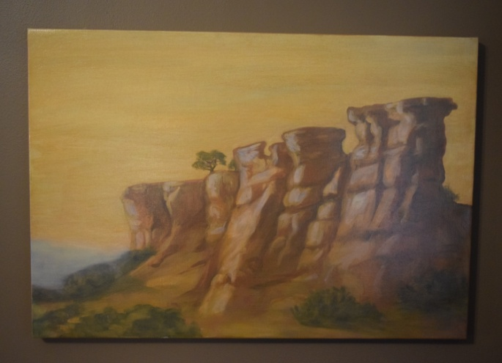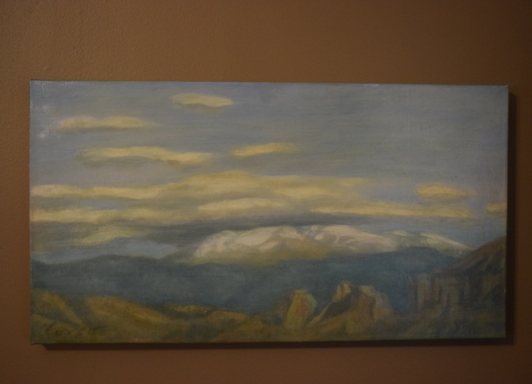
The paintings that David Cooley generously donated are still up for auction/bid. They have been listed on the following sites:
Ebay : http://www.ebay.com/itm/Oil-Paintings-by-Santa-Fe-Artist-Anthony-Corso-/162012155089?ssPageName=ADME:L:LCA:US:1123
Craigslist : http://tulsa.craigslist.org/art/5498867047.html
Ed Payton is encouraging everyone in our class to mention these on their social media sites and emailing the information to friends who might be interested in the paintings.
Here is a blurb about them: Two stunning oil paintings of the New Mexico landscape by acclaimed Santa Fe artist Anthony Corso. One is 24” x 36”; the other is 23” x 15”. The larger work depicts buttes jutting up from the floor of a valley into mesas with a distant mountain range in the background. The smaller work is of clouds hovering over a distant mountain range. Using the rich colors of the southwest, Corso captures the stark beauty of a New Mexico landscape. Corso’s work has been featured in solo shows, group exhibitions and at numerous galleries. His work in public collections includes those of the United Nations, the Port Authority of New York, Chemical Bank and the American Broadcasting Company. More information about the artist, who is presently living in New York, may be found at his website.
These paintings were donated to Maranatha ministries by the original owner. Proceeds will be used for community service work in the Tulsa, OK, area.
SOCIALS:

Road Trip to the Coleman Theatre – The Social Committee is organizing a road trip to Miami, Oklahoma, to the spectacular Coleman Theatre on Sunday, June 12th, at noon, to hear Resident Organist Dennis James play the Mighty Wurlitzer pipe organ while we watch Buster Keaton star in the 1928 silent film Steamboat Bill, Jr. Can’t you smell that popcorn now?

MISSIONS:
Upcoming Maranatha Mission Events:

Serving Dinner at St. Luke’s Redemption Church – May 22nd - Sign ups are now being taken for people available to help serve at this worthwhile event. Please contact Glenna Arnott or Jim Embrey if you are available.

June – Open month for mission
24th July: St Luke's Redemption Church, serving dinner
August – Open month for mission
9th September: Day Center for the Homeless, feeding dinner
October – Open month for mission
November – Open month for mission
December – Neighbor for Neighbor, managing families for photos and presents
25 December: Serving Congregational Brunch to whole church before worship
If you know of a mission opportunity that would fit into Maranatha’s scope of work, let Glenna Arnott or Jim Embrey know so they can look into it for a possible opportunity to serve.

PRAYER VOLUNTEERS:
5/15 Meredith Davison-Wansley
5/22 Pam Sherman 5/29 Lynn Jessee
SPEAKERS:
5/15 Rabbi Charles Sherman IN COMMUNITY HALL
5/22 Rev. Susanna Southard 5/29 Brunch w/Horizons
CLASS PRAYER REQUESTS (Joys):
Please give thanks for the following:

Lee-Lee DeFreitas is celebrating the fact that she got a job and we are proud of her.

Beth Green has been selected as a Top Woman In Media, winning a Folio Award. She will be recognized as an awards ceremony on June 9th at the Yale Club in New York City. Congratulations, Beth!

Paul Staat successfully drove all the way to Houston and is now poised to begin his next phase of treatment prior to a bone marrow transfer from his sister.

Mary Bundren sent the class a sweet note expressing appreciation for all the cards, emails, meals and prayers during her two back surgeries within ten weeks. She is hopeful to recover sufficiently to be back with us by the end of the summer.

Bethany Willyard is recovering from her recent back surgery and was able to go shopping last Saturday.

CLASS PRAYER REQUESTS (Concerns):
Please keep the following in your prayers:

The father of Nancy and Suzan Morgan is back in the hospital and they are exploring assisted living options for their mother, who is resistant to the idea. The situation is very painful and stressful for the family.
A close friend of Lynn Russell’s daughter (Shannon Martin) has been diagnosed with breast cancer that has metastasized to her bones. She has two young children and the family is reeling.
Roger Rowe’s friend’s wife Michelle was in a serious bike accident which left her with numerous broken bones and a long recovery ahead.
The niece of Jim and Julee Embrey was in a car accident and suffered significant injuries. They are grateful that she is alive, but concerned about her prognosis.
Please email our Caranatha Chair Carol Grim at cgrim1@cox.net and copy our President at adale@hallestill.com with concerns that need immediate class response or prayer during the week such as accidents, injuries, deaths, etc. For emergencies, please call Carol at (918) 583-5181 (weekday mornings) or (198) 369-6945 (any other time). For Joys and Concerns to be communicated to the class and incorporated into the newsletter, please email our class mailbox at maranathaclass@gmail.com. I will incorporate them into our newsletter and, if time permits, into our class announcements, next week.

CHURCH WIDE PRAYER REQUESTS:
05/8/16 Boston Avenue Prayer Ministry: “O Beautiful Creator, in your magnificent world of creation teach me to be content but never settled and uncaring. Reveal to me how to use things well and enjoy them without clinging and hoarding. I want to live with open hands. Give me a heart for sharing. Instill in me an awareness of the healing power of creation. Don’t ever let me turn away from the hard questions. Let me live simply, beautifully, and generously all the days of my life. May it come to pass! Amen.” Macrina Wiederkehr Jacques Cunningham, 749 7040, cunnij6@cox.net
-For God’s peace to rule in the hearts of all his children, the Boston Avenue Church & staff, the ministries of Boston Avenue, the Prayer Ministry, the ministers of Boston Avenue & families: David Wiggs, Eva Marie Campbell, Shari Goodwin, Bill Tankersley, Audra Fogle, Bill Crowell, Brenda Reed, Sheri Nellis, Sarah Thornhill, Joel Panciera, Susan Panciera, Debbie Peterson, Paula Gradney Garner, Jose Luis Hernandez, Belynda Clanton, Paul Staat, Hayley St. John, Jennifer Solis
- For Merri Whitaker, the Cookson Mission, the Burroughs students, teachers and staff

Prayer Requests Received on 5/8/16:
- For the Boston Avenue families who have lost these loved ones: Fred Allen, Carl Wright.
- For the Boston Avenue members who are or have been in the hospital: Carolyn Morrison, Suzanne Campbell, Diana Grigg, Ella Gruenberg
- For our first time visitors.
-For General and Annual Conference this month
- For Sanders - their dad died.
- For Taylor Smith, who accidently shot himself in the face eight days ago, with major damage to mouth and brain.
- For a friend who may be struggling in her marriage. Whatever their situation is give them both strength and comfort.
- For my family and my husband to be comfortable communicating with me.
- For women who struggle with infertility.
- For all women who long to be mothers but can’t and had to witness a room full of mothers stand today as part of worship.
- For JoAnn & mother – cancer; Steve & Shelia cancer; Brandee; Celma; Sandra death of husband
- For Cindy Harmon with a recurrence of cancer

ANNOUNCEMENTS:
WE ARE MOVING!!! Just for one week so we can hear Rabbi Sherman in Community Hall this Sunday. Based upon the numbers, our classroom simply couldn’t hold all of Maranatha and Pilgrimage. There will still be coffee & snacks and we will still start announcements at 9:45, with the lesson at 10:00. See you there!
BOY SCOUT SUPPORT NEEDED: Thank you SO MUCH to the ten Maranathans (Is that even a word?) who volunteered to write a brief letter to encourage a young Boy Scout going off to summer camp. People volunteering are the following:
Art Campbell
Kendall Carpenter
Jim Embrey
Scott Gardner
Joey Manduano
Jim McCann
Rob Morgan
Roger Rowe
Scott Solomon
Brenda Worthington

We also appreciate Mickey Maus who volunteered to bring snacks to go in the care packages sent by the church to each Scout. If you could also provide candy, snacks or other non-perishable, non-melting food, please do so. All letters and food items need to be returned to the class no later than Sunday, May 29th, so that the Welcoming Committee can assemble a care package for each boy. Since ours is the oldest continuously chartered troop in the State of Oklahoma, Boston Avenue has been standing behind our Scouts for many, many years. Thank you for continuing this important and meaningful tradition.

NEW STUDY ON SUSTAINING GOD’S CREATION: BAUMC member Caroline Holmes, currently a student at Sewanee, the University of the South majoring in Environment & Sustainability with a minor in Religion & the Environment, is offering an eight week study on being good stewards of God’s creation. The class is offered on Sundays from June 5th through July 24th from 12:15 to 1:15 and will include lunch and discussion of Biblical view of creation, appropriate care for creation and how members of BAUMC can work in our own community. For information or to sign up, email melanielinsky@bostonavenue.org or call (918) 699-0147.
ITALIAN DINNER AUCTION ITEM: For those who purchased the Italian Dinner at the Maranatha Christmas Auction, it will be held on Saturday, May 14th, at Jim & Sherry Griffin’s home, 1376 E. 26th St., Tulsa, OK 74114. Invitations will be sent soon. The hosts for the event are the Griffins, the Donleys and Richard and Jeanie Payton.
RETURNING CHARTER MEMBERS NEED WELCOME VISITS: As indicated in the email sent to the class, charter Maranatha members Sharon and Bruce Chucoski moved back to Tulsa on Tuesday, April 19th. We are hoping that they will decide to rejoin us in the Maranatha Class. If current class members could stop by and welcome them over the next few days at 3728 E. 64th Pl. (Pointe South), that warm Maranatha welcome might just seal the deal!
GARAGE APARTMENT AVAILABLE FROM JAMES KILMAN: A 350 square foot guest house is available for rent on June 1, 2016, by James Kilman close to downtown. The unit includes a stove, refrigerator and built-in queen size Murphy bed with mattress provided. Hook-ups are available for an over/under washer/dryer unit. James is asking $700 per month in rent with water included. Additional utilities (electric and gas) typically run around $150 per month. Please contact James at (918) 557-5131 for additional information or a showing.
COOKSON HILLS MISSION CREW -UPDATED INFORMATION: Applications are being accepted for a mission crew to provide a week of support, maintenance and repair work from June 5th through 10th to assist the Cookson Hills Mission with its continuing mission efforts in the Cherokee Nation. THIS IS FREE TO PARTICIPANTS. WORKERS WILL TRAVEL BACK AND FORTH EACH STAY SO THEY CAN STAY IN THEIR OWN HOMES. WEDNESDAY IS A DAY OFF. WORKERS CAN COME FOR AS MANY DAYS AS THEY ARE ABLE. EVEN ONE DAY WOULD MAKE AN IMPACT ON MISSION WORK. Contact Jim Stilwell at (918) 884-5189 for additional information.
SPAVINAW VBS MISSION TEAM FORMING: Would you like to make a difference in the life of a young child while staying close to home? Come join the mission team that will assist with Vacation Bible School at the Spavinaw United Methodist Church. Although the church has a total membership of 20-25 people, it attracts 50-60 children each year for VBS and needs our help to make this a wonderful experience for them. The buses will leave Boston Avenue each day for the 90 minute drive to Spavinaw where lunch will be provided for you before you return home. Won’t you consider blessing others and being blessed by this endeavor? Contact Penny Sheehan at (918)698-8778 for more information.
CLASS DISCUSSION GUIDELINES - We are a large class with many people who have lots of interesting things to say. In order to give everyone an opportunity to voice their comments, we are incorporating into our weekly lessons the discussion guidelines that Marita Morgan taught us: (1) Only one comment per person per class. (2) Economy of words. (3). Speak loudly so everyone has an opportunity to hear you. Thank you for adhering to these discussion guidelines so that we will all have an opportunity to participate in the discussions and benefit from hearing each other.
2016 Maranatha Officers
President: Jim McCann
VP Curriculum: Angelyn Dale
VP Finance: Bob Russell/Jim Embrey/Dave Grim/Karen Campbell (Emeritus)/Jim McCann
VP Missions: Glenna Arnott/Jim Embrey
Social: Angelyn Dale/Karen Campbell/Sarah Maldonado/Jeanie Payton/Judith Payton
Auction: Judith and Ed Payton
Attendance taker(s)/Secretary: Sharon Earley
Refreshments: Debbie and Scott Morgan
Reporter: Meredith Davison-Wansley
Caranatha: Carol and Dave Grim
Chili Supper: Jim & Julee Embrey
Historian: Pam Low
Treasurer: Susie Butterworth
Web Master: Barbara Meehan

