Today: 22 May 2016 |  | Next Week: 29 May 2016
Birthdays:  Angelyn Dale (22)  Bill Gertsen (22)  Jerry Walker (22)  Jane Smith (25)  Amy Michael (26)  Bethany Willyard (27) |  | Birthdays:  Sharon Bookout (2)  Debra Morgan (2)  Neal Pascoe (4)
Anniversaries:  Rex & Allene Donley (5/25/96)  Gene & Diane Martin (5/27/77)  Bob & Lynn Russell (5/27/05) |  | Anniversaries:  Jeff & Julie Allen (5/30/81)  Terry & Amy Michael (5/30/81)  Clark & Mary Bundren (6/2/79)  Steve & Debbie Jacoby (6/4/76)
Prayer this week:  Meredith Davison-Wansley |  | Prayer next week  Lynn Russell
Speaker this week:  Reverend Susanna Southard |  | Speaker next week:  Brunch with Horizons Class!
Snacks this week:  G = Lynn & Shari Goodwin  H = Debbie & Scott Morgan |  | Snacks next week:  G = Everyone!  H = Everyone!
Boston Avenue UMC: http://www.bostonavenue.org/ |  | Maranatha Class:  http://maranathaclass.org/
MINUTES:
Thank you for the snacks and refreshments. I hope you are looking forward to enjoying the Memorial Day brunch in our class with Maranatha classmates and Horizons guests.
GUESTS: Wyn Dee Baker
FINANCE:
Class expenditures: For any requested class expenditure, please contact a member of the Finance Committee: Bob Russell, Jim Embrey, Dave Grim or Karen Campbell (Emeritus) & Jim McCann.
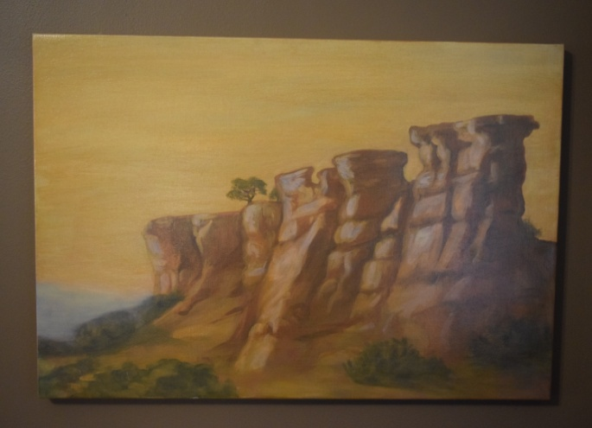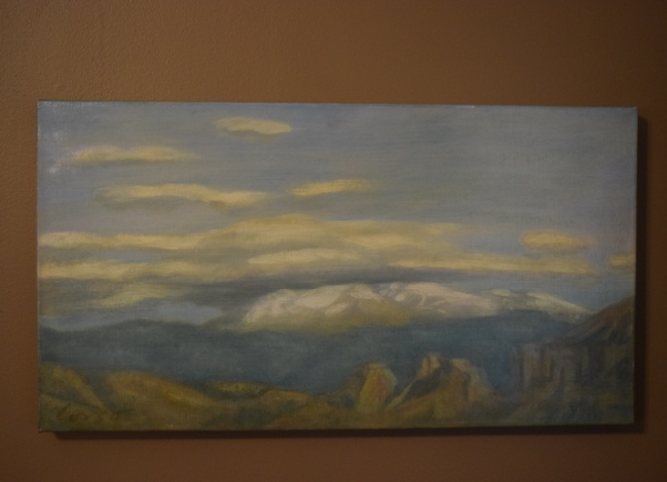
The paintings that David Cooley generously donated are still up for auction/bid. Please mention these on social media sites or email the information to friends who might be interested in the paintings. Two stunning oil paintings of the New Mexico landscape by acclaimed Santa Fe artist Anthony Corso. One is 24” x 36”; the other is 23” x 15”. Corso captures the stark beauty of a New Mexico landscape. Corso’s work has been featured in solo shows, group exhibitions and at numerous galleries. His work in public collections includes those of the United Nations, the Port Authority of New York, Chemical Bank and the American Broadcasting Company. More information about the artist, who is presently living in New York, may be found at his website. These paintings were donated to Maranatha ministries by the original owner. Proceeds will be used for community service work in the Tulsa, OK, area.
SOCIALS:

Road Trip to the Coleman Theatre – Sign-up sheets will be passed in class on 5/29 and 6/5 for the road trip to Miami, Oklahoma, to the spectacular Coleman Theatre on Sunday, June 12th. Tickets are $17.00 to hear Resident Organist Dennis James play the Mighty Wurlitzer pipe organ while we watch Buster Keaton star in the 1928 silent film Steamboat Bill, Jr. We will carpool/caravan and leave at noon and be back between 5:30 and 6:00. Guests are welcome. If you have questions, feel free to contact Angelyn Dale at (918) 638-2353 or adale@hallestill.com.

MISSIONS:
Serving Dinner at St. Luke’s Redemption Church – May 22nd - Thank you so much to everyone who generously devoted their time to working at this mission project. It was important work and you did it well.

Upcoming Maranatha Mission Events:

June – Open month for mission
24th July: St Luke's Redemption Church, serving dinner
August – Open month for mission
9th September: Day Center for the Homeless, feeding dinner
October – Open month for mission
November – Open month for mission
December – Neighbor for Neighbor, managing families for photos and presents
25 December: Serving Congregational Brunch to whole church before worship
If you know of a mission opportunity that would fit into Maranatha’s scope of work, let Glenna Arnott or Jim Embrey know so they can look into it for a possible opportunity to serve.

PRAYER VOLUNTEERS:
5/29 Lynn Jessee

SPEAKERS:
5/29 Brunch w/Horizons 6/5 & 6/12 Michelle LeDoux
CLASS PRAYER REQUESTS (Joys):
Please give thanks for the following:

Bruce and Sharon Chucoski (charter members of Maranatha who had moved out of state) moved back to Tulsa and rejoined Boston Avenue and Maranatha! Hurray!

Richard and Meredith Wansley are thrilled to be expecting another grandchild.

Bethany Willyard thanked everyone for their prayers and concerns during her recent surgery and was pleased to announce that she will be returning to work.

CLASS PRAYER REQUESTS (Concerns):
Please keep the following in your prayers:

When Lynn Russell was taking her father to his chemo treatment, she met a patient who has a desperate need for a wheelchair and cannot afford it. If anyone has one available, please contact Lynn.
Kraemer Luks asked for prayer for Christi who is currently in Honduras.
The kindergarten teacher of Joe Harris’ son lost her leg in an accident.
Please email our Caranatha Chair Carol Grim at cgrim1@cox.net and copy our President at adale@hallestill.com with concerns that need immediate class response or prayer during the week such as accidents, injuries, deaths, etc. For emergencies, please call Carol at (918) 583-5181 (weekday mornings) or (198) 369-6945 (any other time). For Joys and Concerns to be communicated to the class and incorporated into the newsletter, please email our class mailbox at maranathaclass@gmail.com. I will incorporate them into our newsletter and, if time permits, into our class announcements, next week.

CHURCH WIDE PRAYER REQUESTS:
05/22/16 Boston Avenue Prayer Ministry: “There are many times we think we love you well, O God, but upon hearing your call to love you with all our heart, and all our mind, and all our strength, we confess that our love for you is a diluted love, made insipid and flat by lesser loyalties and a divided heart.” Kenneth D. Loeman Jacques Cunningham, 749 7040, cunnij6@cox.net
-For God’s peace to rule in the hearts of all his children, the Boston Avenue Church & staff, the ministries of Boston Avenue, the Prayer Ministry, the ministers of Boston Avenue & families: David Wiggs, Eva Marie Campbell, Shari Goodwin, Bill Tankersley, Audra Fogle, Bill Crowell, Brenda Reed, Sheri Nellis, Sarah Thornhill, Joel Panciera, Susan Panciera, Debbie Peterson, Paula Gradney Garner, Jose Luis Hernandez, Belynda Clanton, Paul Staat, Hayley St. John, Jennifer Solis
- For Merri Whitaker, the Cookson Mission, the Burroughs students, teachers and staff

Prayer Requests Received on 5/22/16:
- For the Boston Avenue families who have lost loved ones
- For the Boston Avenue members who are or have been in the hospital: Taylor Smith, Marge Neal, Ella Gruenberg
- For our first time visitors: Anna Alexander; Janice Allyn; Cheryl & Marvin Barth; Maddie Calhoun; Yuriko Crowell; Rebecca Danel; Marcy & Randy Ellis; Nancy Gunter; Megan Huntsman; Bryan & Jill Johnson; Sandra Meek; Bill & Cathy Munn; Alexandra, Bobby, Libby & Sarah Patton; Carl Renoud; John Slotterback; Betty & Julie Smith; Ron & Rose Unterschuetz; Tracy Walker; Karen Warlick; Wendy & William Watkins
- For Woody & Marilyn Knox who were involved in a multi-car accident in Arizona that included fatalities. Woody & Marilyn’s injuries were not life-threatening, but they are still recovering from the emotional trauma.
- For Lavonne, Jason & Jordon as their husband and father has died; for Ron who now lives with an abdominal feeding tube & hopes will regain the ability to take food by mouth; for my cousin who has lost the ability to swallow due to a stroke and has chosen to take no more food or fluid. His death will be days away.
- For my marriage which is struggling because cannot communicate.
- For Katie Fitchner & Billy Parli both deployed to Iraq Prayers for safe returns home.
- For children & family of Bobbi Witten Bobbi, an Owasso teacher, was killed by being rear ended on HW 169. She is a single mom who left 2 children ages 9 & 12, who were both also injured.
- For the BAUMC class of 2016 to feel the BAUMC family with them as they start new chapters in their lives.
- For a dear friend who is going through a marriage crisis.- for Bill & Bonny Patrick Lost their daughter at 32 yrs who left 4 children. Please pray for the children left behind.
- For Cindy Harmon and John Harmon Thank you prayer ministry and fellow Boston Ave. members for your ongoing prayers. John and myself as I journey through my chemo treatment. For the beautiful cards received and calls as well as text messages. Prayer is what reaches us in our darkest moments. June 6th is my next CT scan. May God bless each of you.
- For God’s peace, favor, mercy & most importantly, his wisdom as I help clients this week with very difficult cases. May God make his presence known to my clients and seen. May God be glorified in the process.
- For Joann and Martin cancer; Shelia & Steve cancer; Krancee; Capes
- for Annual Conference this week

ANNOUNCEMENTS:
BOY SCOUT SUPPORT NEEDED: Thank you SO MUCH to the ten Maranathans who volunteered to write a letter to encourage a young Boy Scout going off to summer camp. These are the following:
Art Campbell Kendall Carpenter Jim Embrey Scott Gardner
Joey Manduano Jim McCann Rob Morgan Roger Rowe
Stuart Solomon Brenda Worthington

We also appreciate Mickey Maus who volunteered to bring snacks to go in the care packages sent by the church to each Scout. If you could also provide candy, snacks or other non-perishable, non-melting food, please do so. All letters and food items need to be returned to the class no later than Sunday, May 29th.

NEW STUDY ON SUSTAINING GOD’S CREATION: BAUMC member Caroline Holmes, currently a student at Sewanee, the University of the South majoring in Environment & Sustainability with a minor in Religion & the Environment, is offering an eight week study on being good stewards of God’s creation. The class is offered on Sundays from June 5th through July 24th from 12:15 to 1:15 and will include lunch and discussion of Biblical view of creation, appropriate care for creation and how members of BAUMC can work in our own community. For information or to sign up, email melanielinsky@bostonavenue.org or call (918) 699-0147.
GARAGE APARTMENT AVAILABLE FROM JAMES KILMAN: A 350 square foot guest house is available for rent on June 1, 2016, by James Kilman close to downtown. The unit includes a stove, refrigerator and built-in queen size Murphy bed with mattress provided. Hook-ups are available for an over/under washer/dryer unit. James is asking $700 per month in rent with water included. Additional utilities (electric and gas) typically run around $150 per month. Please contact James at (918) 557-5131 for additional information or a showing.
CLASS DISCUSSION GUIDELINES - We are a large class with many people who have lots of interesting things to say. In order to give everyone an opportunity to voice their comments, we are incorporating into our weekly lessons the discussion guidelines that Marita Morgan taught us: (1) Only one comment per person per class. (2) Economy of words. (3). Speak loudly so everyone has an opportunity to hear you. Thank you for adhering to these discussion guidelines so that we will all have an opportunity to participate in the discussions and benefit from hearing each other.
2016 Maranatha Officers
President: Jim McCann
VP Curriculum: Angelyn Dale
VP Finance: Bob Russell/Jim Embrey/Dave Grim/Karen Campbell (Emeritus)/Jim McCann
VP Missions: Glenna Arnott/Jim Embrey
Social: Angelyn Dale/Karen Campbell/Sarah Maldonado/Jeanie Payton/Judith Payton
Auction: Judith and Ed Payton
Attendance taker(s)/Secretary: Sharon Earley
Refreshments: Debbie and Scott Morgan
Reporter: Meredith Davison-Wansley
Caranatha: Carol and Dave Grim
Chili Supper: Jim & Julee Embrey
Historian: Pam Low
Treasurer: Susie Butterworth
Web Master: Barbara Meehan

