Today: 15 May 2016 |  | Next Week: 22 May 2016
Birthdays:  Clark Bundren (22) |  | Birthdays:  Angelyn Dale (22)  Bill Gertsen (22)  Jerry Walker (22)  Jane Smith (25)  Amy Michael (26)  Bethany Willyard (27)
Anniversaries:  David & Kendall Carpenter (5/21/83) |  | Anniversaries:  Rex & Allene Donley (5/25/96)  Gene & Diane Martin (5/27/77)  Bob & Lynn Russell (5/27/05)
Prayer this week:  Pam Sherman |  | Prayer next week  Meredith Davison Wansley
Speaker this week:  Rabbi Charles Sherman |  | Speaker next week:  Reverend Susanna Southard
Snacks this week:  G = Sherry & Jim Griffin  H = Richard & Meredith Wansley |  | Snacks next week:  G = Lynn & Shari Goodwin  H = Debbie & Scott Morgan
Boston Avenue UMC: http://www.bostonavenue.org/ |  | Maranatha Class:  http://maranathaclass.org/
MINUTES:
Thank you for the snacks and refreshments and for being such great sports about moving to Community Hall to hear our terrific lesson from Rabbi Sherman. I am already working to secure him as a speaker again for next year!
GUESTS:
I saw Bruce and Sharon Chucoski in the melee, but am not sure they count as guests since they were charter members of Maranatha. Anyway, we were delighted to have them back with us and hope they will rejoin us as members. As for other guests in that sea of humanity, your guess is as good as mine!
FINANCE:
Class expenditures: For any requested class expenditure, please contact a member of the Finance Committee: Bob Russell, Jim Embrey, Dave Grim or Karen Campbell (Emeritus) & Jim McCann.
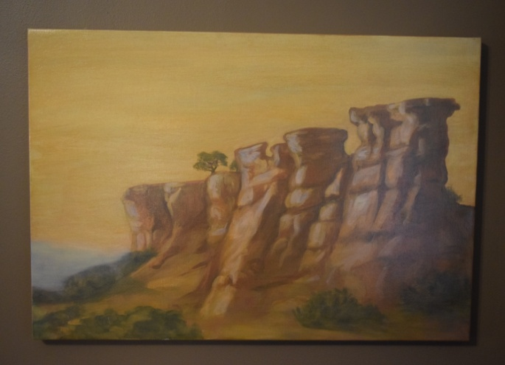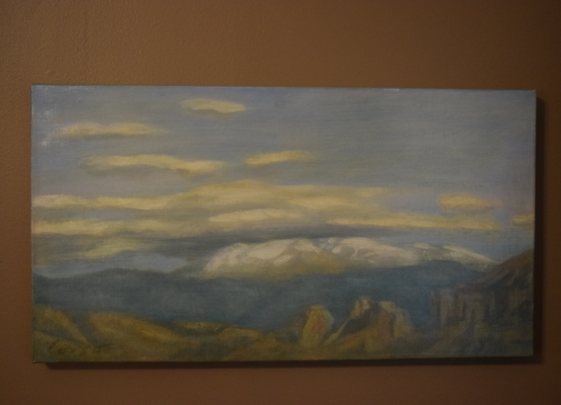
The paintings that David Cooley generously donated are still up for auction/bid. Ed Payton is encouraging everyone in our class to mention these on their social media sites and emailing the information to friends who might be interested in the paintings.
Here is a blurb about them: Two stunning oil paintings of the New Mexico landscape by acclaimed Santa Fe artist Anthony Corso. One is 24” x 36”; the other is 23” x 15”. The larger work depicts buttes jutting up from the floor of a valley into mesas with a distant mountain range in the background. The smaller work is of clouds hovering over a distant mountain range. Using the rich colors of the southwest, Corso captures the stark beauty of a New Mexico landscape. Corso’s work has been featured in solo shows, group exhibitions and at numerous galleries. His work in public collections includes those of the United Nations, the Port Authority of New York, Chemical Bank and the American Broadcasting Company. More information about the artist, who is presently living in New York, may be found at his website.
These paintings were donated to Maranatha ministries by the original owner. Proceeds will be used for community service work in the Tulsa, OK, area.
SOCIALS:

Road Trip to the Coleman Theatre – Sign-up sheets will be passed in class on 5/15, 5/22, 5/29 and 6/5 for the road trip to Miami, Oklahoma, to the spectacular Coleman Theatre on Sunday, June 12th. Tickets are $17.00 to hear Resident Organist Dennis James play the Mighty Wurlitzer pipe organ while we watch Buster Keaton star in the 1928 silent film Steamboat Bill, Jr. We will carpool/caravan and leave at noon and be back between 5:30 and 6:00. Guests are welcome. If you have questions, feel free to contact Angelyn Dale at (918) 638-2353 or adale@hallestill.com.

MISSIONS:
Upcoming Maranatha Mission Events:

Serving Dinner at St. Luke’s Redemption Church – May 22nd - If you have signed up to serve dinner this Sunday, May 22nd, Glenna or Jim will provide you with additional information. The class appreciates your representing us in this important service. If you have not signed up but are available, please call Jim Embrey or Glenna Arnott.

June – Open month for mission
24th July: St Luke's Redemption Church, serving dinner
August – Open month for mission
9th September: Day Center for the Homeless, feeding dinner
October – Open month for mission
November – Open month for mission
December – Neighbor for Neighbor, managing families for photos and presents
25 December: Serving Congregational Brunch to whole church before worship
If you know of a mission opportunity that would fit into Maranatha’s scope of work, let Glenna Arnott or Jim Embrey know so they can look into it for a possible opportunity to serve.

PRAYER VOLUNTEERS:
5/22 Pam Sherman 5/29 Lynn Jessee

SPEAKERS:
5/22 Rev. Susanna Southard 5/29 Brunch w/Horizons
CLASS PRAYER REQUESTS (Joys):
Please give thanks for the following:

Reverend EvaMarie Campbell sent the class a note expressing appreciation for our donation to the Children’s Department and Burroughs Elementary School.

CLASS PRAYER REQUESTS (Concerns):
Please keep the following in your prayers:

Martha Blevins’ mother has been in Saint Francis with no clear diagnosis other than being extremely weak. The goal for Martha and Dan is to get her to OMM for therapy and for her to eventually return home with Martha’s father. All Martha and Dan request at this time is prayer.
Please email our Caranatha Chair Carol Grim at cgrim1@cox.net and copy our President at adale@hallestill.com with concerns that need immediate class response or prayer during the week such as accidents, injuries, deaths, etc. For emergencies, please call Carol at (918) 583-5181 (weekday mornings) or (198) 369-6945 (any other time). For Joys and Concerns to be communicated to the class and incorporated into the newsletter, please email our class mailbox at maranathaclass@gmail.com. I will incorporate them into our newsletter and, if time permits, into our class announcements, next week.

CHURCH WIDE PRAYER REQUESTS:
05/15/16 Boston Avenue Prayer Ministry: “O Beautiful Creator, in your magnificent world of creation teach me to be content but never settled and uncaring. Reveal to me how to use things well and enjoy them without clinging and hoarding. I want to live with open hands. Give me a heart for sharing. Instill in me an awareness of the healing power of creation. Don’t ever let me turn away from the hard questions. Let me live simply, beautifully, and generously all the days of my life. May it come to pass! Amen.” Macrina Wiederkehr Jacques Cunningham, 749 7040, cunnij6@cox.net
-For God’s peace to rule in the hearts of all his children, the Boston Avenue Church & staff, the ministries of Boston Avenue, the Prayer Ministry, the ministers of Boston Avenue & families: David Wiggs, Eva Marie Campbell, Shari Goodwin, Bill Tankersley, Audra Fogle, Bill Crowell, Brenda Reed, Sheri Nellis, Sarah Thornhill, Joel Panciera, Susan Panciera, Debbie Peterson, Paula Gradney Garner, Jose Luis Hernandez, Belynda Clanton, Paul Staat, Hayley St. John, Jennifer Solis
- For Merri Whitaker, the Cookson Mission, the Burroughs students, teachers and staff

Prayer Requests Received on 5/15/16:
- For the Boston Avenue families who have lost these loved ones: Sue Medlin, Carolyn Morrison
- For the Boston Avenue members who are or have been in the hospital: Molly Guernsey, Allison Hardin, Marge Neal, Ella Gruenberg
- For our first time visitors.
- For General and Annual Conference this month
- For Michelle who will have hernia surgery this week
- For Hope who leaves Tuesday on her summer Nicaraguan mission trip
- For the Holy Spirit to refresh my spirit, soul & body. For me to follow His leading this week so I may cooperate with God.
- For Louise Reid who is struggling with her health
- For Charles Herndon who will have the last in his series of chemo - 5 ½ hours
- For Debbie who is struggling with headaches and needs rest and healing

ANNOUNCEMENTS:
BOY SCOUT SUPPORT NEEDED: Thank you SO MUCH to the ten Maranathans (Is that even a word?) who volunteered to write a brief letter to encourage a young Boy Scout going off to summer camp. There are BAUMC notecards in the classroom that can be used or other paper is fine as well. People volunteering are the following:
Art Campbell
Kendall Carpenter
Jim Embrey
Scott Gardner
Joey Manduano
Jim McCann
Rob Morgan
Roger Rowe
Scott Solomon
Brenda Worthington

We also appreciate Mickey Maus who volunteered to bring snacks to go in the care packages sent by the church to each Scout. If you could also provide candy, snacks or other non-perishable, non-melting food, please do so. All letters and food items need to be returned to the class no later than Sunday, May 29th, so that the Welcoming Committee can assemble a care package for each boy. Since ours is the oldest continuously chartered troop in the State of Oklahoma, Boston Avenue has been standing behind our Scouts for many, many years. Thank you for continuing this important and meaningful tradition.

NEW STUDY ON SUSTAINING GOD’S CREATION: BAUMC member Caroline Holmes, currently a student at Sewanee, the University of the South majoring in Environment & Sustainability with a minor in Religion & the Environment, is offering an eight week study on being good stewards of God’s creation. The class is offered on Sundays from June 5th through July 24th from 12:15 to 1:15 and will include lunch and discussion of Biblical view of creation, appropriate care for creation and how members of BAUMC can work in our own community. For information or to sign up, email melanielinsky@bostonavenue.org or call (918) 699-0147.
RETURNING CHARTER MEMBERS NEED WELCOME VISITS: Charter Maranatha members Sharon and Bruce Chucoski moved back to Tulsa on Tuesday, April 19th. We are hoping that they will decide to rejoin us in the Maranatha Class. If current class members could stop by and welcome them over the next few days at 3728 E. 64th Pl. (Pointe South), that warm Maranatha welcome might just seal the deal!
GARAGE APARTMENT AVAILABLE FROM JAMES KILMAN: A 350 square foot guest house is available for rent on June 1, 2016, by James Kilman close to downtown. The unit includes a stove, refrigerator and built-in queen size Murphy bed with mattress provided. Hook-ups are available for an over/under washer/dryer unit. James is asking $700 per month in rent with water included. Additional utilities (electric and gas) typically run around $150 per month. Please contact James at (918) 557-5131 for additional information or a showing.
COOKSON HILLS MISSION CREW -UPDATED INFORMATION: Applications are being accepted for a mission crew to provide a week of support, maintenance and repair work from June 5th through 10th to assist the Cookson Hills Mission with its continuing mission efforts in the Cherokee Nation. THIS IS FREE TO PARTICIPANTS. WORKERS WILL TRAVEL BACK AND FORTH EACH STAY SO THEY CAN STAY IN THEIR OWN HOMES. WEDNESDAY IS A DAY OFF. WORKERS CAN COME FOR AS MANY DAYS AS THEY ARE ABLE. EVEN ONE DAY WOULD MAKE AN IMPACT ON MISSION WORK. Contact Jim Stilwell at (918) 884-5189 for additional information.
SPAVINAW VBS MISSION TEAM FORMING: Would you like to make a difference in the life of a young child while staying close to home? Come join the mission team that will assist with Vacation Bible School at the Spavinaw United Methodist Church. Although the church has a total membership of 20-25 people, it attracts 50-60 children each year for VBS and needs our help to make this a wonderful experience for them. The buses will leave Boston Avenue each day for the 90 minute drive to Spavinaw where lunch will be provided for you before you return home. Won’t you consider blessing others and being blessed by this endeavor? Contact Penny Sheehan at (918)698-8778 for more information.
CLASS DISCUSSION GUIDELINES - We are a large class with many people who have lots of interesting things to say. In order to give everyone an opportunity to voice their comments, we are incorporating into our weekly lessons the discussion guidelines that Marita Morgan taught us: (1) Only one comment per person per class. (2) Economy of words. (3). Speak loudly so everyone has an opportunity to hear you. Thank you for adhering to these discussion guidelines so that we will all have an opportunity to participate in the discussions and benefit from hearing each other.
2016 Maranatha Officers
President: Jim McCann
VP Curriculum: Angelyn Dale
VP Finance: Bob Russell/Jim Embrey/Dave Grim/Karen Campbell (Emeritus)/Jim McCann
VP Missions: Glenna Arnott/Jim Embrey
Social: Angelyn Dale/Karen Campbell/Sarah Maldonado/Jeanie Payton/Judith Payton
Auction: Judith and Ed Payton
Attendance taker(s)/Secretary: Sharon Earley
Refreshments: Debbie and Scott Morgan
Reporter: Meredith Davison-Wansley
Caranatha: Carol and Dave Grim
Chili Supper: Jim & Julee Embrey
Historian: Pam Low
Treasurer: Susie Butterworth
Web Master: Barbara Meehan

