Today: 5 June 2016 |  | Next Week: 12 June 2016
Birthdays:  Claudia Altshuler (5)  Diane Martin (5)  Lisa Tallent (6)  Peggy Lewis (7)  James Kilman (8) |  | Birthdays:  Julie Allen (12)  Debra Pascoe (12)  June Kooker (13)  Denise Klein (18)
Anniversaries:  Rob & Andrea Davis (6/6/92)  Larry & Claudia Altshuler (6/10/89) |  | Anniversaries:  Paul & Mary Staat (6/16/90)
Prayer this week:  Angelyn Dale |  | Prayer next week  Sharon Chucoski
Speaker this week:  Michelle Finamore |  | Speaker next week:  Michelle Finamore
Snacks this week:  G = Becky Morris  H = Margaret Been |  | Snacks next week:  G = Steve & Debbie Jacoby  H = Mickey & Carol Maus
Boston Avenue UMC: http://www.bostonavenue.org/ |  | Maranatha Class:  http://maranathaclass.org/
MINUTES:
Thank you for the snacks and refreshments. Michelle LeDoux Finamore provided the first of a two part lesson on critical information for dying with dignity and grace.
GUESTS: Wyn Dee Baker (2nd time), Lewis Hill, Annie Jones, Taylor Pocopanni
FINANCE:
Class expenditures: For any requested class expenditure, please contact a member of the Finance Committee: Bob Russell, Jim Embrey, Dave Grim or Karen Campbell (Emeritus) & Jim McCann.
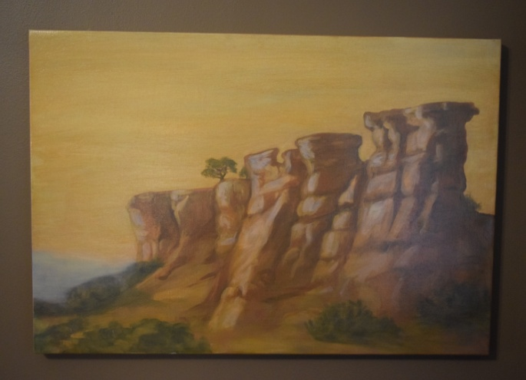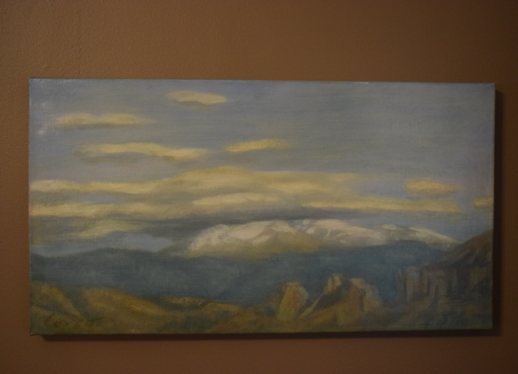
The paintings that David Cooley generously donated are still up for auction/bid. Please mention these on social media sites or email the information to friends who might be interested in the paintings. Two stunning oil paintings of the New Mexico landscape by acclaimed Santa Fe artist Anthony Corso. One is 24” x 36”; the other is 23” x 15”. Corso captures the stark beauty of a New Mexico landscape. Corso’s work has been featured in solo shows, group exhibitions and at numerous galleries. His work in public collections includes those of the United Nations, the Port Authority of New York, Chemical Bank and the American Broadcasting Company. More information about the artist, who is presently living in New York, may be found at his website. These paintings were donated to Maranatha ministries by the original owner. Proceeds will be used for community service work in the Tulsa, OK, area.
SOCIALS:

Road Trip to the Coleman Theatre – Seventeen of us are going on Sunday afternoon to Miami, Oklahoma, to the spectacular Coleman Theatre to hear Resident Organist Dennis James play the Mighty Wurlitzer pipe organ while we watch Buster Keaton star in the 1928 silent film Steamboat Bill, Jr. It should be great fun!

MISSIONS:
Upcoming Maranatha Mission Events:

June – Open month for mission
24th July: St Luke's Redemption Church, serving dinner
August – Open month for mission
9th September: Day Center for the Homeless, feeding dinner
October – Open month for mission
November – Open month for mission
December – Neighbor for Neighbor, managing families for photos and presents
25 December: Serving Congregational Brunch to whole church before worship
If you know of a mission opportunity that would fit into Maranatha’s scope of work, let Glenna Arnott or Jim Embrey know so they can look into it for a possible opportunity to serve.

PRAYER VOLUNTEERS:
6/12 Sharon Chucoski 6/19 Richard Wansley
6/26 Scott Morgan

SPEAKERS:
6/12 Michelle Finamore 6/19 & 6/26 Steve Dickie
CLASS PRAYER REQUESTS (Joys):
Please give thanks for the following:

Bob and Jill Thomas’ daughter Olivia beautifully represented herself, her family, Boston Avenue, Tulsa and the USA during the Miss USA Pageant on Sunday night when she relinquished her crown. We are all so proud of her!

CLASS PRAYER REQUESTS (Concerns):
Please keep the following in your prayers:

Paul Staat received his bone marrow transplant from his sister on June 8th this week and describes it on Facebook as, “this treatment is currently kicking me, but I plan to kick it back.”
Kyla Rogers, granddaughter of Pam and John Sherman was bitten by a brown recluse spider and has been hospitalized for a blood transfusion and concern about possible necrotic tissue damage.
Jim Seymour told another class member that doctors were recently able to remove a portion of his cancer.
Please email our Caranatha Chair Carol Grim at cgrim1@cox.net and copy our President at adale@hallestill.com with concerns that need immediate class response or prayer during the week such as accidents, injuries, deaths, etc. For emergencies, please call Carol at (918) 583-5181 (weekday mornings) or (198) 369-6945 (any other time). For Joys and Concerns to be communicated to the class and incorporated into the newsletter, please email our class mailbox at maranathaclass@gmail.com. I will incorporate them into our newsletter and, if time permits, into our class announcements, next week.

CHURCH WIDE PRAYER REQUESTS:
06/5/16 Boston Avenue Prayer Ministry: “I know beyond a shadow of a doubt, with no proof, that my grandfather prayed for all of us kids. And as it turns out, if one person is praying for you, buckle up. Things can happen.” Anne Lamott Jacques Cunningham, 749 7040, cunnij6@cox.net
-For God’s peace to rule in the hearts of all his children, the Boston Avenue Church & staff, the ministries of Boston Avenue, the Prayer Ministry, the ministers of Boston Avenue & families: David Wiggs, Eva Marie Campbell, Bill Tankersley, Audra Fogle, Brenda Reed, Sheri Nellis, Joel Panciera, Susan Panciera, Debbie Peterson, Paula Gradney Garner, Jose Luis Hernandez, Belynda Clanton, Paul Staat, Hayley St. John, Jennifer Solis
- For Merri Whitaker, the Cookson Mission, the Burroughs students, teachers and staff

Prayer Requests Received on 6/5/16:
- For the Boston Avenue families who have lost loved ones: Marge Neal, Catherine Nixon
- For the Boston Avenue members who are or have been in the hospital: Ella Gruenberg, Gerry Arnold
- For our first time visitors
- For Cindy Harmon who will have a CT scan in her fight with cancer.
-For our mission trip to Cookson this week
- For Peggy Cooper who just took on the 6 month prayer challenge for three different areas and who will make these her intensive prayer life!
- For the 2016 Chapel Choir tour to have smooth travels, fun times, God honoring performances and new friendships for all.
- For you to be my vision, Lord and to show me what Your kingdom in my life looks like and empower me to go on the adventure that is walking with You.
-For Nick Millan, whose father has had a stroke & may not survive. He is in his 50’s & leaving a young family.
- For Linda Rosson whoser cancer is back and for hope & help in working through this.
- For the Carden family – death of Aukd; Pattosen family – death of Ken; Brendee; Johnson family – cancer; Ellis family death of Amy
- For Don Souders who contracted COI while in hospital and has severe pain & is needing emotional uplift.
- For Kyla Rogers who is being treated at St. John for a brown recluse bite. Her reaction has become systemic and she will be there for a while.
- For Suzanne Kenner whose cancer has metastasized in liver.

ANNOUNCEMENTS:
CLASS DISCUSSION GUIDELINES - We are a large class with many people who have lots of interesting things to say. In order to give everyone an opportunity to voice their comments, we are incorporating into our weekly lessons the discussion guidelines that Marita Morgan taught us: (1) Only one comment per person per class. (2) Economy of words. (3). Speak loudly so everyone has an opportunity to hear you. Thank you for adhering to these discussion guidelines so that we will all have an opportunity to participate in the discussions and benefit from hearing each other.
2016 Maranatha Officers
President: Jim McCann
VP Curriculum: Angelyn Dale
VP Finance: Bob Russell/Jim Embrey/Dave Grim/Karen Campbell (Emeritus)/Jim McCann
VP Missions: Glenna Arnott/Jim Embrey
Social: Angelyn Dale/Karen Campbell/Sarah Maldonado/Jeanie Payton/Judith Payton
Auction: Judith and Ed Payton
Attendance taker(s)/Secretary: Sharon Earley
Refreshments: Debbie and Scott Morgan
Reporter: Meredith Davison-Wansley
Caranatha: Carol and Dave Grim
Chili Supper: Jim & Julee Embrey
Historian: Pam Low
Treasurer: Susie Butterworth
Web Master: Barbara Meehan

