Today: 26 June 2016 |  | Next Week: 3 July 2016
Birthdays:  William Meyer (26)  Roger Rowe (29)  Sue Madden (1) |  | Birthdays:  David Cooley (5)  Patty Banes (8)
Anniversaries:  Lynn & Shari Goodwin (6/28/75)  Alan & Jane Smith (6/30/79) |  | Anniversaries:  Jim & Sherry Stinson (7/7/62)  Dave & Carol Grim (7/8/72)  Gary & Patti Smith (7/9/83)
Prayer this week:  Scott Morgan |  | Prayer next week  Bob Russell
Speaker this week:  Rev. Steve Dickey |  | Speaker next week:  Dr. Mouzon Biggs
Snacks this week:  G = Skip & Paula Scott  H =Rob & Andrea Davis |  | Snacks next week:  G = Julie & Jeff Allen  H = Roger & Charlotte Rowe
Boston Avenue UMC: http://www.bostonavenue.org/ |  | Maranatha Class:  http://maranathaclass.org/
MINUTES:
Thank you for the snacks and refreshments. Reverend Steve Dickey was our speaker and we appreciated his insightful lesson.
GUESTS: None this week.
FINANCE:
Class expenditures: For any requested class expenditure, please contact a member of the Finance Committee: Bob Russell, Jim Embrey, Dave Grim or Karen Campbell (Emeritus) & Jim McCann.
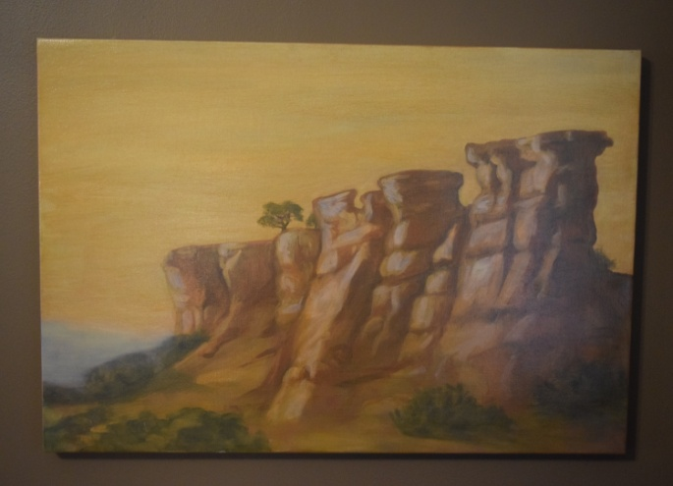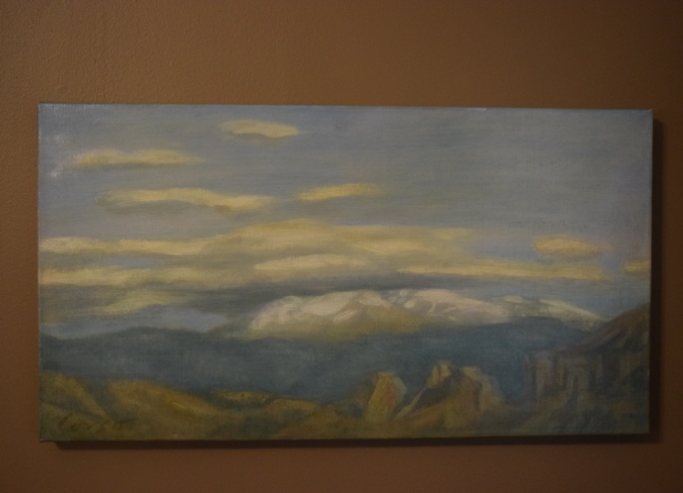
The paintings that David Cooley generously donated are still up for auction/bid. Please mention these on social media sites or email the information to friends who might be interested in the paintings. Two stunning oil paintings of the New Mexico landscape by acclaimed Santa Fe artist Anthony Corso. One is 24” x 36”; the other is 23” x 15”. Corso captures the stark beauty of a New Mexico landscape. Corso’s work has been featured in solo shows, group exhibitions and at numerous galleries. More information about the artist, who is presently living in New York, may be found at his website. These paintings were donated to Maranatha ministries by the original owner. Proceeds will be used for community service work in the Tulsa, OK, area.
SOCIALS:

Class Outing To See BABA’s Production of ANYTHING GOES – On July 31st, we will end the month by going out to lunch as a class after the 11:00 service and then attending the closing matinee performance of Anything Goes. We will start sending sign-up lists around on Sunday, July 3rd, so that we can purchase tickets early and get great seats. There is lots of Maranatha talent in the cast and on the production crew so we should have a great time supporting our own! Put July 31st on your calendar and plan to enjoy those tapping toes in Anything Goes!

MISSIONS:
Upcoming Maranatha Mission Events:
24th July: St Luke's Redemption Church, serving dinner
August – Open month for mission
9th September: Day Center for the Homeless, feeding dinner
October – Open month for mission
November – Open month for mission
December – Neighbor for Neighbor, managing families for photos and presents
25 December: Serving Congregational Brunch to whole church before worship
If you know of a mission opportunity that would fit into Maranatha’s scope of work, let Glenna Arnott or Jim Embrey know so they can look into it for a possible opportunity to serve.

PRAYER VOLUNTEERS:
7/3 Roger Rowe 7/10 Bob Russell
7/17 Janet Purinton 7/24 Carol Grim
7/31 Mark Butterworth
SPEAKERS:
7/3, 7/10, 7/17, 7/24, 7/31 Dr. Mouzon Biggs
8/7 & 8/14 Roger Coffey
8/21 & 8/28 Gary Peluso-Verdend
CLASS PRAYER REQUESTS (Joys):
Please give thanks for the following:

Scott and Debra Morgan are grateful that their son has gotten a job which excites him and offers all the bells, whistles and benefits!

Molleigh McCann, daughter of Jim McCann & Angelyn Dale, returned home from her semester abroad in Rio de Janeiro with neither the zika virus nor a Brazilian boyfriend.

CLASS PRAYER REQUESTS (Concerns):
Please keep the following in your prayers:

Paul Staat is continuing to recover from the bone marrow transplant from his sister on June 8^{th.}. Paul’s doctors say he is doing really well and is ahead of the healing curve. Both Paul and Mary appreciate all the prayers and support from our class
Bethany Willyard and Michael Caballero currently have two of Michael’s children visiting for the summer, which makes three teenagers in the home. This is causing significant friction.
Susan Panciera is recovering from surgery on June 16th. Doctors inserted a plate where she broke her elbow in three places while on Choir Tour with the Chapel Choir.
Please email our Caranatha Chair Carol Grim at cgrim1@cox.net and copy our President at adale@hallestill.com with concerns that need immediate class response or prayer during the week such as accidents, injuries, deaths, etc. For emergencies, please call Carol at (918) 583-5181 (weekday mornings) or (198) 369-6945 (any other time). For Joys and Concerns to be communicated to the class and incorporated into the newsletter, please email our class mailbox at maranathaclass@gmail.com. I will incorporate them into our newsletter and, if time permits, into our class announcements, next week.

CHURCH WIDE PRAYER REQUESTS:
06/26/16 Boston Avenue Prayer Ministry: “O Heart of My Heart, Where did you go, Jesus, when you went away? Did you move deeper into my heart? I have discovered that you left cures for my troubled heart all around me. I am trying to make use of them: fresh air, deep breaths, stars and wide-open space, music and song, light and darkness, poetry, prayer, beauty, and more. What good medicine for my soul! It is always in my reach and for this I thank you. Keep moving deeper into my heart. Teach me the dance of trust. O Heart of my Heart, dance me into the lives of all who need healing. Amen.” Macrina Wiederkehr Jacques Cunningham, 749 7040, cunnij6@cox.net

-For God’s peace to rule in the hearts of all his children, the Boston Avenue Church & staff, the ministries of Boston Avenue, the Prayer Ministry, the ministers of Boston Avenue & families: David Wiggs, Eva Marie Campbell, Bill Tankersley, Audra Fogle, Brenda Reed, Sheri Nellis, Joel Panciera, Susan Panciera, Debbie Peterson, Paula Gradney Garner, Jose Luis Hernandez, Belynda Clanton, Paul Staat, Hayley St. John, Jennifer Solis, Sara Pugh Montgomery
- For Merri Whitaker, the Cookson Mission, the Burroughs students, teachers and staff

Prayer Requests Received on 6/26/16:
- For the Boston Avenue families who have lost loved ones: Eva Jo Sheehan, Rosemary Darrough, June Barber, Bud Langdon
- For the Boston Avenue members who are or have been in the hospital: Ella Gruenberg, Paul Staat, John Haws, Stan Medlin ,Suzanne Campbell, Aloah Kincaid
- For our first time visitors:
- For my son-in-law Edward Hicks who had heart surgery and complications putting in a pace maker, and his wife Rhonda
- For my brother R.L. in hospital with broken hip
- For Eddie Diaz, returning to college after taking 2 years off, and has broken up with partner
- For the participants of the Great Unknown camp to experience God’s joy & peace throughout the upcoming week and for the lessons learned to be lasting & permanent.
- For me to experience more of the order and peace of God. For my confusion to clear
- For June, the family of Jarold Lawless his passing; Martin & Justin cancer; Steve & Shelia cancer; Brandee
- For Henry Selby who is undergoing a lengthy hip surgery, and will need healing and comfort from pain.
- For Paulette Goble, whose lymphoma has returned for the third time and needs her health
- For John struggling with addiction, loneliness, life choices
- For my mother who has high blood pressure, a virus and high glucose

ANNOUNCEMENTS:

BOSTON AVENUE SUMMIT Those of you who have not yet taken a Spiritual Formation Class have another opportunity on Friday, July 22nd from 6:00 p.m. to 9:30 p.m. and Saturday, July 23rd from 8:30 a.m. to 5:00 p.m. It will be led by Pat Luna, Rev. David Wiggs and Rev. Sara Pugh Montgomery. Child care is available. To register, call (918) 699-0147. This is a powerful way to spend a weekend!

CLASS DISCUSSION GUIDELINES - We are a large class with many people who have lots of interesting things to say. In order to give everyone an opportunity to voice their comments, we are incorporating into our weekly lessons the discussion guidelines that Marita Morgan taught us: (1) Only one comment per person per class. (2) Economy of words. (3). Speak loudly so everyone has an opportunity to hear you. Thank you for adhering to these discussion guidelines so that we will all have an opportunity to participate in the discussions and benefit from hearing each other.
2016 Maranatha Officers
President: Jim McCann
VP Curriculum: Angelyn Dale
VP Finance: Bob Russell/Jim Embrey/Dave Grim/Karen Campbell (Emeritus)/Jim McCann
VP Missions: Glenna Arnott/Jim Embrey
Social: Angelyn Dale/Karen Campbell/Sarah Maldonado/Jeanie Payton/Judith Payton
Auction: Judith and Ed Payton
Attendance taker(s)/Secretary: Sharon Earley
Refreshments: Debbie and Scott Morgan
Reporter: Meredith Davison-Wansley
Caranatha: Carol and Dave Grim
Chili Supper: Jim & Julee Embrey
Historian: Pam Low
Treasurer: Susie Butterworth
Web Master: Barbara Meehan

